

UNIVERSITA’ DEGLI STUDI DI FIRENZE
SCUOLA DI ECONOMIA E MANAGEMENT



DISPENSA/HANDOUT

CdS SECI
Lingua inglese B003923

Oral exam (Mod.B)
2° semestre a.a. 2020/2021

Dott.ssa I. Cziraky (A-L) Dott.ssa I. Martini (M-Z)

CONTENTS

Steps to follow before discussing a text at the oral examination.......….... p. 3-4

Journalistic texts - The Economist
1. Green on green …………………………………………………………... p.5-6
2. In Search of the good company (CSR)…………………………………... p.7-8

Textbook excerpts
3. Globalisation and Inequality within Countries…………………………... p.9

Glossary………………………………………………………………...….. p.14-15

Evaluation grid…………………………………………………………… p.16
Steps to follow before discussing a text at the oral examination

Discussing a text satisfactorily, does not only mean understanding the facts reported in the text. You will have to consider also the viewpoints, controversial aspects, implications, and writer’s position that may emerge in the text. Comprehending these points in the text will help you to express your own ideas about the issues during the oral examination. It is therefore essential for you to read the text using the strategies and skills you learned and applied in the 1st semester.

- Skim the text to understand the main idea:
Read and reflect on the title/headings/subtitle(s);
- Study visual images, graphs or tables and consider how they are related to the title/subtitle(s);
- Read the first paragraph (or two paragraphs if they are short) representing the introduction in the text.
- Read the first one/two sentence(s) of each paragraph to get the main idea of the text.

- Scan the text to:
- Identify key words/expressions related to important concepts;
- Re-read each paragraph and underline the main points in each paragraph. Underline only the important words and phrases, not supporting examples;
- Read each paragraph to verify if there are different perspectives presented in the text;
- Decide how the text concludes and consider the writer’s position, if this is expressed;
- Read the final paragraph to understand how the conclusion is linked to the introduction;
- Verify how the title/headline is related to the content of the text and to any visuals if included in the text.

During the oral examination:
You should be able to discuss the text in YOUR OWN words. Do NOT memorize entire sentences from the text and then ‘recite’ them.
- Begin by saying in one or two sentences what the text is generally about;
- Briefly summarize the text;
- Make sure you use key words and important specialized terminology;
- Explain the conclusion of the text;
- In addition, you should be prepared to discuss:
  - puns in the title and other interesting figurative or idiomatic language;
  - graphs, tables or images;
  - important concepts/ideas mentioned in the text;
  - contrasting positions (e.g. in favour vs. against, advantages vs. disadvantages);
  - the writer’s position on the issue(s) discussed in the text;
  - your position on the issue(s) discussed;
  - similarities and/or differences from the corresponding situation in Italy.

N.B. Make sure your pronunciation/word stress is as correct as possible. You can use a dictionary to check pronunciation or the Merriam-Webster Dictionary Online (http://www.m-w.com), which has sound files to let you hear how words are pronounced. You can also ask your professor.
Green on green --
Jan 29th 2009
From the Economist

FOR all its stirring rhetoric, the government’s record on renewable energy is poor. Geographically, Britain is ideally placed, enjoying (or enduring) some of the windiest weather and heaviest seas of any European country. Yet in 2005 (believe it or not, the most recent year for which comparable figures are available) Britain got less than 2% of its energy from renewable sources (mostly wind). This was considerably below the European average of 6.7% and far behind countries such as Denmark (16.2%) or Sweden (29.8%).

One single project could provide an enormous boost. The river Severn, Britain’s longest, which flows from Wales to the Bristol Channel, has a tidal range of 15 metres, the second highest in the world. Engineers have long fantasised about harnessing all that energy, and with climate change and energy security now pressing political problems, ministers are taking them seriously. On January 26th the government published a shortlist of possible projects, including three barrages (essentially gigantic dams) and two tidal lagoons (manmade tanks in the sea which fill up and empty with the tide).

It is easy to see the attraction of such schemes. Tidal energy is the best-behaved of
renewable sources. Unlike wind or wave power (or even hydroelectricity, which depends on the rain), tides—governed by the immutable laws of celestial mechanics—are predictable. The sheer size of some of the plans are impressive too. When the tide is flowing fastest, the biggest option—a ten-mile, £22 billion barrage running from Weston-super-Mare to Cardiff (see map)—could generate 8.6 gigawatts, around a seventh of Britain’s peak consumption and more than every other renewable-electricity source combined. Although its average output would be far below its peak, it could still supply around 5% of Britain’s electricity every year.

Such a scheme could put a noticeable dent in British carbon emissions, but greens
concerned about the local environment are unhappy. The Severn estuary is an important habitat for birds; large barrages would destroy or damage much of it, as well as interfere with fish stocks in the river. Friends of the Earth, an environmental lobby group, thinks offshore lagoons might be a useful compromise.

Others object on economic grounds. Ministers admit that the biggest proposal would
require taxpayer funding. A report by Frontier Economics, a consultancy, argues that the same amount of renewable power could be obtained more cheaply with other technologies such as wind turbines. A barrage could affect shipping into Bristol, a big port. Some simply think it would be an eyesore.

A final decision on what project to go for and when is at least a year away. The
Conservatives (who may well be in power when it is taken) say they are not opposed; yet even if construction went ahead it could hardly be finished until after 2020.

But there are other reasons too for politicians to support the project. Like the Hoover Dam, built at the height of the Great Depression in America, a Severn barrage, the British government claims, could create tens of thousands of jobs and lots of work for firms. And as one of the world’s largest engineering projects, it would, of course, be a long-lasting monument to whichever politician approved it.

Exercises:
1. Select a title for each of the seven paragraphs.
a. Greens unhappy with impact on environment. Paragraph ___
b. Providing employment. Paragraph ___
c. The Severn Tidal Power Project. Paragraph ___
d. Tidal Power is predictable. Paragraph ___
e. Economic Objections. Paragraph ___
f. Britain fails to exploit its renewable energy potential. Paragraph ___
g. A long wait for the benefits. Paragraph ___

CORPORATE SOCIAL RESPONSIBILITY (CSR)

The European Commission (2001) defines CSR as “a concept whereby companies integrate social and environmental concerns in their business operations and in their interaction with their stakeholders on a voluntary basis.” This definition has a number of important implications. Firstly, the fact that CSR is the integration of social and environmental concerns within business operations means that CSR is not just philanthropy. CSR is not so much about what enterprises do with their profit, but how they make that profit. Secondly, interaction with stakeholders is a crucial aspect of CSR which requires dialogue and partnership with stakeholders such as trade unions, public authorities, NGOs (non-governmental organisations). Thirdly, by describing CSR as voluntary, this definition implies that CSR relates to what enterprises can do in the social and environmental fields over and above what the are required to do by law.

In search of the good company
Economist 2007

The debate about the social responsibilities of companies is heating up again
IF YOU believe what they say about themselves, big companies have never been better citizens. In the past decade, “corporate social responsibility” (CSR) has become the norm in the boardrooms of companies in rich countries, and increasingly in developing economies too. Most big firms now pledge to follow policies that define best practice in everything from the diversity of their workforces to human rights and the environment. Criticism of CSR has come mostly from those on the free-market right, who intone Milton Friedman's argument that the only “social responsibility of business is to increase its profits” and fret that business leaders have capitulated to political correctness. But in a new twist to the debate, a powerful critique of CSR has just been published by a leading left-wing thinker.
In his new book, “Supercapitalism”, Robert Reich, an economist who served as labour secretary under Bill Clinton, denounces CSR as a dangerous diversion that is undermining democracy. Mr. Reich believes that companies “cannot be socially responsible, at least not to any significant extent”, and that CSR activists are being diverted from the more realistic and important task of getting governments to solve social problems. Debating whether Wal-Mart or Google is good or evil misses the point, he says, which is that governments are responsible for setting rules that ensure that competing, profit-maximising firms do not act against the interests of society.
One after another, Mr Reich trashes the supposed triumphs of CSR. Socially responsible firms are more profitable? Nonsense. Certainly, companies sometimes find ways to cut costs that coincide with what CSR activists want: Wal-Mart adopts cheaper “green” packaging, say, or Starbucks gives part-time employees health insurance, which reduces staff turnover. But “to credit these corporations with being ‘socially responsible' is to stretch the term to mean anything a company might do to increase profits if, in doing so, it also happens to have some beneficent impact on the rest of society,” writes Mr Reich.
Worse, firms are using CSR to fool the public into believing that problems are being addressed, he argues, thereby preventing more meaningful political reform. As for politicians, they fail to make real changes to the regulations that make such misbehaviour possible.
What will CSR advocates make of this? Few will dispute that government has a crucial role to play in setting the rules of the game. But Mr Reich has it “exactly backwards”, says John Ruggie of Harvard University. If citizens and politicians were prepared to do the right thing, he says, “there would be less need to rely on CSR in the first place.”
Thoughtful advocates of CSR also concede that companies are unlikely to do things that are against their self-interest. The real task is to get them to act in their enlightened long-term self-interest, rather than narrowly and in the short term. Mr Reich dismisses this as mere “smart management” rather than social responsibility. But done well, CSR can motivate employees and strengthen brands, while also providing benefits to society. Telling firms they need not act responsibly might cause them to under-invest in these opportunities, and to focus excessively on short-term profits.
Though Mr. Reich’s book hits many targets, both bosses and CSR activists are likely to dismiss it as fundamentally unworldly and to agree with Simon Zadek, the boss of AccountAbility, a CSR lobby group. “The ‘whether in principle' conversation about CSR is over,” he says. “What remains is ‘What, specifically, and how?'”

Globalisation and Inequality within Countries

“recent research finds that trade liberalisation is associated more with increased inequality in poor countries and outsourcing by multinationals has increased the relative demand for skilled labour, increasing the pay gap to unskilled labour”.

Supporters of the anti-globalisation movement argue that globalisation has increased inequality between and within nations and in particular that it has marginalised the poor in less economically developed countries (LEDC) and left behind the poorest countries. Meanwhile, more moderate mainstream politicians argue that the poor must invest in education to take advantage of globalisation.
Under a standard textbook model, globalisation should benefit the poor and reduce inequality, and the poorest countries and less educated workers should have the greatest opportunity to benefit from globalisation. However, evidence from specific LEDCs following trade liberalisation and from cross-country studies does not suggest that trade liberalisation generally reduces inequality in poor countries and in fact frequently suggests that trade liberalisation is associated with increased inequality. For example, after Mexico embarked on a broad liberalisation of trade and foreign investment, the return to schooling increased: white-collar real hourly wages increased by 13.4 percent 1984-90, while blue-collar wages fell by 14.0 percent. The biggest rise in inequality was observed in firms engaged in export industries. Rising wage inequality in Mexico is linked to capital inflows from abroad. Outsourcing by Northern multinationals shifted production towards skill-intensive goods, thereby increasing the relative demand for skilled labour with Multinational firms and joint ventures paying higher wages. Most recent research finds that trade liberalisation is associated with increased inequality in poor countries. In sum, the evidence does not support the expected theoretical effects of globalisation consistently reducing inequality in poor countries. Another striking example is India where call centres tend to employ middle-class Indians who can speak with an American accent with which U.S customers are familiar. Multinationals and exporters in LEDCs also pay manufacturing wages substantially above the norm for the country.
To summarise, it seems that the presence of some industries in which foreign investors typically hire medium-skill workers who are high-skill relative to others in their country may help explain why there is not a clear equalising effect of trade in poor countries.

(source: in: International Poverty Centre (IPC), Poverty in Focus, June 2007)

GLOSSARY
Fair trade
The Fairtrade Foundation, Oxfam and Traidcraft agree the following definition of fair trade: “Fair Trade is an alternative approach to conventional international trade. It is a trading partnership which aims at sustainable development for excluded and disadvantaged producers. It seeks to do this by providing better trading conditions, by awareness raising and by campaigning”.
Whenever you see a Fair Trade label, you can feel secure in the knowledge that your purchase helps —and doesn’t harm—people and the planet.
The systems put in place by fair trade organizations ensure that whatever price the market may allocate to goods such as cocoa and tea, the growers involved are guaranteed a minimum price by the purchaser. And, if market prices exceed this minimum, fair trade farmers receive a premium in order to finance development goals. As a result, growers are not only prevented from sinking into poverty at the whim of commodity markets, but can also plan and implement community initiatives. Figure 1 provides an illustration from the cocoa market of how the guaranteed fair trade price compares with market prices over time.
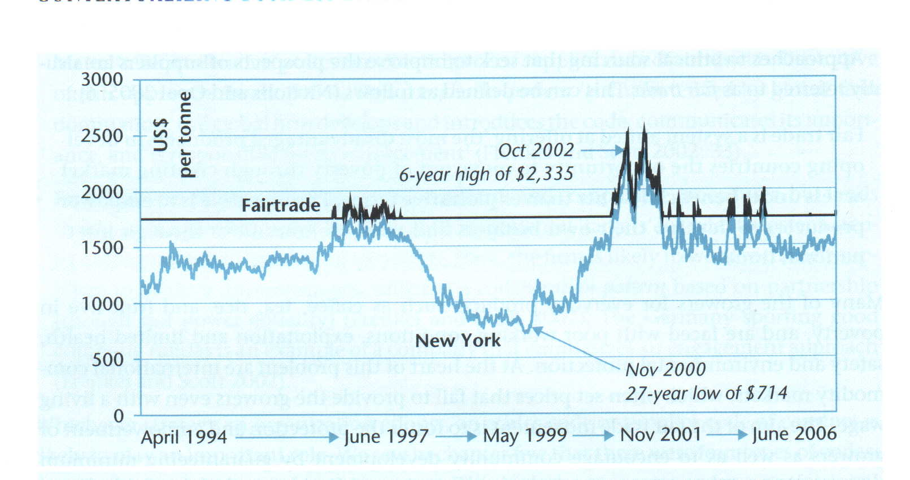

Figure 1. The cocoa market 1994-2006: comparison of Fairtrade and New York exchange prices
NB: Fairtrade minimum prices = $1600/tonne + $150 premium. When the New York price is $1600 or above, then the Fairtrade price = New York price + $150 premium.

Sustainable energy
Sustainable energy is defined as energy which, in its production or consumption, has minimal impacts on human health and the healthy functioning of vital ecological systems, including the global environment, and that can be supplied continuously to future generations on earth. Such forms of energy include, but are not limited to the following: solar thermal, wind, hybrid wind-solar, fuel cell, small-scale hydro-electric, tidal and wave. This definition specifically excludes nuclear and fossil fuel energy or their ‘improvements’ as an option.

Evaluation grid

Main points evaluated at oral exam (level B2)

- Content
- Accuracy of structures
- Fluency
- Range of Vocabulary
- Pronunciation (i.e. word stress)

