UNIT 6

1) Key concepts: Marketing Brands
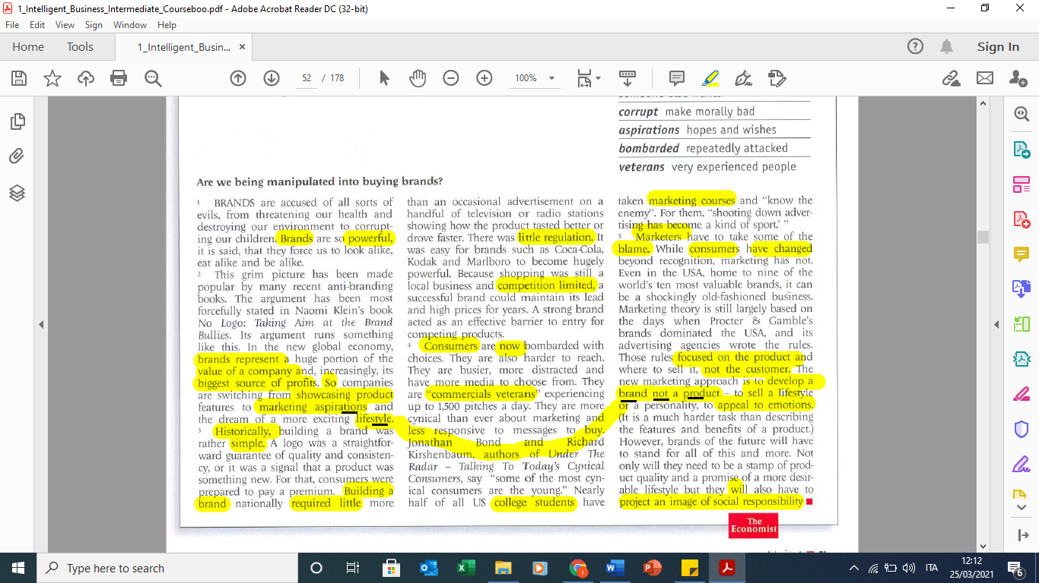

2) p.50 questions in order

