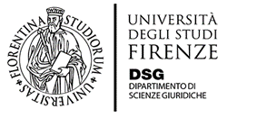
Seminars under the Agreement between
Pretoria University and University of Florence
Corso di diritto privato
(Prof. Sara Landini)

Image
Rights in Comparative Perspective
Prof. Steve Cornelius
Director of the Centre for Intellectual Property Law
Department of Private Law
University of Pretoria

29th september 2017 h. 9,30- 11

