**UNIT 6**

1) Key concepts: *Marketing Brands*

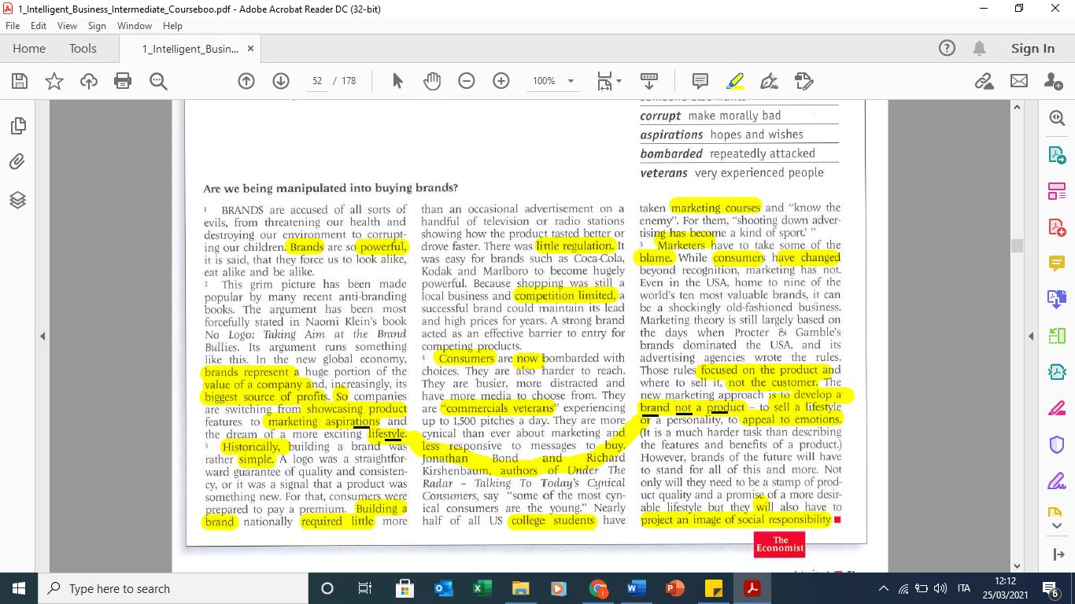

2) p.50 questions in order

