The development of marriage: the evolution and legal framework of marriage
By Federica Violo

  - The historical evolution of marriage

Marriage is one of the largest and strongest institutions in our society. Marriage means the union of two persons with the purpose of forming a family. It is interesting to discover the origins and the reasons which allow it to keep its persistence and stability despite the passing of centuries. The various cultures and religions of the world show us the different forms and marriage celebration rules, which are the result of an evolution which took place in time. My attention will focus on the history of the western Roman Empire and Christianity.
The etymology of the word marriage is derived from the union of two Latin words: “mater” means mother and “munus” means task, duty. According to the Roman law, it was purely a maternal task to give legitimacy to the biological offspring born from the union of parents. Thus the term attributed to its etymology, stands out even more clearly the importance of the procreative purpose, which is along with the affective , a constitutive and essential component of marriage. In ancient Rome, the term marriage was defined as the union of a man and a woman, based only on natural law. In the archaic period, the form of marriage practiced was called “cum manus” and it focused on the subjugation of women to the authority of a man. The marriage was only relevant to the social and religious level, which manifested itself also during the celebration that took place with magic and religious rituals. Over time the marriage “cum manus” was replaced by the marriage “sine maun”. It replaced the old values and opened up to the concept of freedom and consent of the spouses and it followed the legitimacy of divorce.
For the bride and groom before coming to the celebration of marriage, it was necessary to follow first the engagement called “sponsalia”. The engagement was confirmed by a written document in the presence of witnesses. The groom promised to marry his girlfriend giving her as engagement ring. Allowing them to through with the wedding celebration. Usually it took place in June and began at dawn in the native home of the bride. The bride for the occasion wore a white tunic, tied at the waist by a belt that her future husband would have dissolved in the nuptial bed. On her head, she wore an orange veil that covered her face. The rite of the ceremony began when the bride walked to their future home, whilst accompanied by three children, and one of them would carry a hawthorn torch which would have been lit later on the hearth as a symbol of good omen. On the way she was also followed by family and friends who brought with them gifts for the newlyweds. Arriving at the gates of the new house, it was the duty of the bride to cover the corners of the door with a pink ribbon and wool covered with oil and lard which symbolized the removal of any bad omens. The future husband would then wait at the entrance of the dwelling, after which both recited a formula of promise, after which the husband took his bride and accompanied her inside the house, symbolizing the entrance of the new mistress. At the end of the ritual they proceeded to the banquet.
With the advent of Christianity, the church consecrated the marriage that was contracted according to the Roman law. In 313 with the Edict of Milan there was the introduction of the possibility of divorce and remarriage of widowers. In the period of the Middle Ages, the church affirmed the importance for the institution of marriage to follow the rules of German law based on the absolute authority of the husband towards his wife. It was introduced in Italy by the Lombard. For the bride and groom, before arriving at the wedding it, was important to enter into the promise of marriage called in Latin “desponsatio”. The day of the wedding included the reading of a document containing all the information on the property of the spouses. At that time the law also established the age of the couple, fourteen years for men and twelve for women.
With the rise of the power of Pope Nicholas I, the church reconsidered the marriage as a vision focused on the consent of the spouses. This was the decision that revolutionized the vision of
the church towards marriage. Throughout the Middle Ages the church forbade incest, it was not possible to get married to spouses who had kinship until the seventh grade. Then, the church took on the task to investigate possible inbreeding, thereby nullifying incestuous marriages between spouses. It took a real legal role and these were the bases that saw the entry of marriage in canon law, becoming a religious ceremony. The task of the priests, was to ensure that between the bride and groom there was no kinship and that between them there was free will to marry.
In 1545-1563, the period of the Council of Trent, the church defined the necessary legal forms of a valid marriage canon. This was the period of the Counter Reformation, the Protestant doctrines supported the “laicizzazione” of marriage, which provided the separation of the civil and religious aspect of marriage. In this period, Martin Luther argued, that marriage was the result of human relations and there was nothing sacred in it. Martin Luther re-entered the marriage into civil law and the possibility of divorce. In Protestant countries, civil marriage was widely popularized, while in Catholic countries, marriage was under the guidance of canon law until the French Revolution.
The civil marriage was introduced for the first time in Europe with the French Constitution of the 4th September of 1791 and then governed in the Napoleonic Code of 1804. In Italy, the “Albertino” Code considered marriage an act of disciplined worship and celebrated by the Catholic Church without producing effects in the Italian system. Those who wished to have productive marriage for the Church and for the country, had to support two different double celebrations, a religious form and a civil one. Soon the process of secularization also arrived in Italy, in particular with the birth of the Civil Code issued on 2nd April 1865, which came into force on 1st January of 1866 and it introduced the celebration of civil marriage, calling it the only form of valid marriage for all citizens. There were strong reactions from the Catholic church which exerted an exclusive power over the marriage that now was believed to have bypassed. Therefore, on 11th February 1929, a “Concordato Lateranenze” was signed between the Catholic Church and the Italian state. The kingdom of Italy gave rise to the “concordatorio” marriage, recognizing civil effects of marriages celebrated in a catholic ceremony. In Italy the desire to celebrate marriage in a church has also civil effects, and is called “concordatorio” marriage; it is ruled by canon law. The civil law provides obstacles which must be met, to allow for a valid civil marriage.

  - The types of marriage active in Italy: civil marriage; “concordatario” marriage; “acattolico” marriage

The Italian Constitution came into force on 1st January 1948, and regulates marriage in Article 29: “The Republic recognizes the rights of the family as a natural society founded on marriage. Marriage is the moral and legal equality of the spouses within the limits established by law and guarantee family unity”. The Constitution dedicated to the family and marriage are the Articles 29, 30 and 31, the provisions of which are mutually connected. In the Civil Code, which entered into force on 16th March 1942, the term marriage is used both for the same act of marriage of the report that follows. It is a “legal transaction” regulated by articles 79 to 230 of Title VI of the Civil Code entitled “Of the people and the family” and specifies the requirements for getting married and the various implications. The law provides for three modes of celebration: civil, “concordatario” , “acattolico”.

    - The civil marriage in a legitimate family

The Civil Code defines marriage as the “act by which a man and a woman commit themselves to realizing a communion of life and suffering, a stable coexistence founded on assistance and mutual respect and the search for a unity of intent”.
With the term “marriage” this gives rise to the marital status of the relationship that ensues the effects that characterize it. If we analyse marriage under a structural point of view, it is a “negozio bilaterale” in which you exercise a constitutional freedom. Talking about the “negozio” because the effects enshrined judicial systems and must to be intended by the parties, while “bilaterale” that spouses are the only stipulating parties. Moreover, marriage is negotiated as private law, strictly personal, not patrimonial. It is defined as private law because it represented an exercise of private autonomy, strictly personal does not admit representation and finally not patrimonial as it sought to safeguard interests relating to the person, in the constitution of the communion of life between spouses and not assets. It is not applicable to the regulation of contracts, however is checked compared with the specific characteristics of the marriage.
The civil marriage refers to marriage which produces effects only for the state and therefore fully covered by the civil code , that regulates the conditions required to the future spouses to contract, the preliminary formalities to be carried out, the celebration, advertising and terms of appeal. According to the Italian’s legal system, the characterizing element for marriage is the difference in sex. Nevertheless, the historical evolution of the concept of family is still missing the acceptance by society of the union of persons of the opposite sex and the same sex. In the rest of Europe i.e.: Belgium, Netherlands , Norway ,Portugal ,Spain , Sweden , Iceland , France marriage even among people of the same sex, is recognised:
The Civil Code provides for certain conditions for future spouses to enter into marriage. They are:
- must not be under age, only with permission of the court can get married even those who have turned 16 years old;
- must be prohibited for mental infirmity;
- they may not be bound by a previous marriage;
- the woman can’t contract a new marriage only after three hundred days from the dissolution, by the cancellation or termination of the civil effect, divorce, of the previous marriage;
- can’t marry each other: ascendants, grandparents, and the descendants in a straight line, children born in marriage or born out of wedlock;
- brothers and sisters;
- uncle and niece, aunt and nephew;
- kin, relatives of the spouse, in a straight line; or affinity in the collateral line in the second degree; the adopter, the adoptee and his descendants;
- adopted children of the same person;
- the adoptee and the children of adopter, the adopted and the spouse of the adopter and the adoptee’ s spouse;
- people of which one has been convicted of murder or attempted consumed on the other spouse.
The absence or existence of any of these requirements, prevents marriage and prohibits the bride and groom and the registrar to celebrate the marriage. These obstacles can be divided into absolute and relative, dispensable and not dispensable. The absolute cause of exclusion in the celebration of any marriage are: age, disqualification, lack of freedom of the state. The relative grounds are kinship, affinity, adoption and murder. Dispensable are the kinds of obstacles which can be removed through judicial authorization: age, kinship and affinity. Not dispensable are the remaining .
The most important aspect is the “libertà matrimoniale” which is part of the fundamental freedoms that protects the person and it is internationally recognized by the European Court of Human Rights. The individual is then guaranteed to be able to choose whether or not to contract into marriage without being influenced by individuals or by the state. The state can also adjust this freedom without denying or limiting without justification. The commitment made by one of the intending spouses to enter into marriage can be revoked without limit until the time of the celebration (art.79 commercial code). Marriage as mentioned earlier is an act of particular significance for the person as it will affect his/her entire life; it is preceded by a period of preparation that allows the mutual knowledge of the intending spouses. This waiting time will allow the couple to take the decision to make a commitment called c.d engagement or wedding vows. The request of the wedding to the publication pursuant to art. 81 commercial code means that you have the intention of getting a promise of marriage. Let’s talk about leaving because according to our system you are free to change your mind until last moment. The rupture can have unjustified reason for breaking the promise; those who are not serious enough to call into question the commitment to celebrate the wedding. However justified those reasons those serious reasons that were recorded before or after the promise, for example the discovery of not being able to have children.
Another important requirement is the obligation to make the publication by an officer of the civil state and must be after at least four days of their completion. Talking about banns of matrimony, they refer to the inclusion on the website by the municipality of an act containing the generality of the intending spouses. It is the duty of the officer’s registrar to ensure that there are no impediments to the marriage. The publication is the form of “pubblicità-notizia”; the aim is to inform the people who are going to celebrate their wedding and is intended to alert those who want to oppose this, however, is not the same thing as c.d opposition to marriage.The demand for publications must be made by both spouses or by a third party who has received authorization from these means of power of attorney issued by private deed, or who has parental responsibility or who exercises supervision for children aged between sixteen and eighteen years, the officer of one of the spouses of the common state of residence civil and must contain the following information:
- the name, last name, date and place of birth, citizenship, residence, freedom of state of each of the spouses;
- if there is an obstruction of kinship, affinity, adoption or affiliation between them, if are already married;
- if they have been declared disqualified for mental infirmity;
- if they were condemned as murder consummated or attempted on the other spouse.
The act of publication is placed on the town’s website for at least eight consecutive days. The court, at the request of the couple, may order, for serious reasons, the reduction of the period of eight days of the publication for very serious reason, such as one of the prospective spouses dies, the omission of the same publications, when the spouses declare before the clerk of the court that there were no grounds for refusal. The cost of these publications include a revenue stamp of the amount of sixteen euro if the bride and groom are residing in the town; it costs twice as much when one of the prospective spouses is a resident of another municipality.
Who is authorized to oppose to the marriage, that is the power granted to certain persons to take legal action to obtain the suspension of the celebration are:
- the parents of the couple; in case of lack of parents in the ascending and collateral to the third degree;
- the guardian or trustee;
- the prosecutor;
- spouse;
- former spouse.
These individuals may appeal to the tribunal of the place where publications are made. The Chairman of the tribunal shall determine by decree the appearance of the parties before the panel for a date between three and ten days from the submission of the application. The appeal may also be submitted after the deadline for inclusion in online publishing, but prior to the marriage. The President of the court may decide to suspend the celebration of marriage until the opposition is remove. The civil marriage is held by the officer of the civil state which can be the mayor, the deputy mayor, a city councilman, a municipal employee for an indefinite time which has attended a special course or, even, an Italian citizen who is eligible for election as councilman. The civil registrar must wear the flag. The celebration takes place in the Municipal House in which is made the request for publication in a room open to the public. In the presence of two witnesses, one for each side, there is a reading of the following:
- Art.143: “Reciprocal rights and duties of the spouses”;
- Art. 144: “Address of family life and residence of the family”;
- Art. 147: “Duty to the children, of the Civil Code”.

The registrar celebrant receives the couple who claims they wants to be husband and wife, declares them united in marriage, and welcomes, as appropriate, future declarations regarding the choice of the regime of separation of property, or the choice of law applicable to property relations, as well as recognition of natural children, now children born out of wedlock. Only in exceptional cases is it possible to celebrate the wedding out of the Municipal House, or when illness or other impediment justified the civil officer for example when one of the spouses is prevented from reaching the Town Hall. In this case it is necessary the presence of four witnesses instead of two. The marriage is valid even if the consent is expressed before an apparent registrar, so that the latter armies publicly (art. 113 commercial code) that is, if his will is flawed as a threatened. Immediately after the celebration in Part I of the register of civil status, the marriage certificate is drawn up; it will be read and signed by the couple, the witnesses and by the registrar. Possession of marital status means to have the feature in the reality of married life. Its elements are:
- the name: when the wife is recognized with the same surname as her husband;
- the treatment: when there is a coexistence based on respect for marital obligations;
- the fame: when the couple is socially recognized as husband and wife.
- The State law provides two types of property regimes that spouses can choose:
- the communion of goods;
- the separation of property;
The community of property is the property regime that is automatically adopted if the spouses do not require more. The community property states that all purchases made by the family after marriage, are part of the common heritage. The separation of property should instead be specifically requested by the spouses; each spouse retains exclusive ownership of property acquired during marriage.

    - The “ Concordatario” marriage

The second type of marriage is rite, is termed “concordatario”. This type of religious marriage takes place in front of the Minister of Catholic worship and the state law recognizes the same effects to the civil marriage. The catholic marriage has the same effects of civil marriage and must comply with the following procedures, which are: the marriage has to be celebrated by the Minister of Catholic worship following the norms of canon law and must be reported in the registers of civil status.
Before the “concordatario” marriage, the bride and groom have to follow the premarital course from a parish of their choice and a course that lasts two to three months done by a priest, along with other future couples. It is a time of prayer where they confront issues of reflection on the future of married life. The bride and groom should contact their parish priest or pastor of the church when they have chosen to make the celebration to secure the church and the marriage date and start the paperwork for the marriage. The following documents must be delivered to the plaintiff:
- birth certificates;
- certificates of residence;
- citizenship certificates;
For the religious part:
- the Baptism certificate, which will be released by the parish with whom the person has been baptized;
- confirmation of the certificate, if he or she has not been confirmed, they must do so before marriage;
- the certificate of “ecclesiastical free state”; this certificate serves to certify that the applicant has not been previously married according to religious rite. This document may be replaced by a concerned oath in the parish;
- the certificate of participation in premarital course;
- clearance church: it is a document that must be requested at the Curia if the spouses want to get married at a different parish, outside the municipality of residence. It is the task of the parish priest releases the request for publication at the town hall.
Before the “concordatario” marriage is planned, following a dual regime publications. Once the withdrawal of the certificate of past publications is completed, the bride and groom have to take it to the pastor of the Church in which they will celebrate the marriage. The pastor after an interview with the bride and groom will release the document of their religious consensus, thus confirming the date of marriage. The marriage takes place according to the norms of canon law, such as to the formal requirement of manifestation of the spouse matrimonial consent. It is necessary to have the presence of two witnesses for part; in case of three witness, one will not sign the copy of the marriage certificate that is transmitted in the City, but only the one that remains to the Church. After Mass, the parish priest reminds to the spouses that the marriage produces civil effects and gives them the reading of the articles of the Civil Code concerning the rights and duties of the spouses , that is the art. 143, 144 and 147.
Immediately after the wedding the priest must complete the marriage certificate, in duplicate, signed by the same priest, by the spouses and the witnesses. In the marriage’s, the parish priest indicates the full name of the spouses, the indication of the place and the date under which the celebration and the pastor general. On the act of contract marriage according to the Catholic church spousal rite can also be inserted signs of spouses allowed by the civil law, that is the choice of the regime and recognition of natural children. The pastor must then send a copy of the act, within five days of celebration, to the registrar of the municipality in which the marriage took place, so that they proceed to its transcription having received the marriage certificate, the registrar will have to transcribe it in the appropriate registers in the twenty-four hours from receipt, and shall communicate that they have complied with the parish priest. If the religious marriage was not transcribed, then the civil registry remains a religious act devoid of effects in the Italian legal system. The transcription of the act has not only, therefore, a simple advertising function, declarative, but also constitutive character. This is critical element for the production of civil effects of Catholic marriage that are made retroactively, and from the day of the celebration. So, marriage has civil effects promptly transcribed immediately after the celebration. If marriage was celebrated irregularly because it lacked the publication, the official state before transcribing it , must provide to post a notice of marriage at the gates of the town hall that has spent the period required by law that are eight days, there must be opposition from anyone and then the registrar may proceed to the transcript which is called: “trascrizione tempestiva ritardata” . The situation is different in the case of the late transcription that occurs when the marriage certificate is not sent the registrar within five days after the celebration; in this case the officer can proceed to the transcript only at the request of the couple, then the couple must confirm at the time of the master transcription expressed during the celebration. For the pastor who refuses or does not send the marriage certificate without cause, spouses can request compensation. A particular type of marriage that is not transcribed it promptly called “matrimonio segreto” that the church can celebrate for serious and urgent reasons. It is celebrated by the parish priest, the witnesses and is reported in a secret register kept by the

bishop. It is a marriage that lacks the civil effects and transcripts, which are sent back to the time when the secret reasons terminate.
There are some cases where the law states that the “concordatario” marriage can’t achieve the civil effects; in such cases the marriage may not be transcribed, for example:

- when the couple are not of age that civil law requires for the celebration, eighteen years or sixteen, if authorized by the Juvenile Court;
- when there is an overriding impediment to the civil law, namely:
- when one of the spouses is interdicted for mental infirmity;
- when between the spouses exist another valid marriage for civil purposes;
- when no impediments arising from a crime;
- when no impediments arising from affinity in a straight line.

In the presence of an impediment, the marriage can be transcribed when the action of nullity or cancellation provided for by civil law cannot be made. In the absence of publications, the “concordatario” marriage can be transcribed in the registers of civil status. The registrar must verify that there are no impediments. It is important to have the necessary documents, it must be present a notice containing particulars of the couple, the date and the place where the celebration took place and the name of the minister who celebrated the marriage. This warning will remain posted for ten consecutive days within which the opposition provided by the Civil Code can be made. Late transcriptions follow the transcript request after five days of celebration of the marriage. The law allows this type of transcription only if two conditions are met:

- that it is requested by both spouses or even only by one of them, but with the knowledge and without the opposition of the other;
- that the couple have kept continuously free state , civil law, from the moment of the celebration to that of the transcription request.

    - The “Acattolico” marriage

The Italian state protects the interests of citizens who want to marry, for a type of marriage that has both civilian and religious effects and who practice a different religion from the Catholic one, which is permitted by the state. They have allowed those who profess principles and do not follow rituals that go against public order or morality. The Italian state recognizes another form of marriage, the “acattolico” marriage; it refers to the marriage that takes place in front of the minister of a non- catholic worshiper. The “acattolico” marriage is understood as a civil marriage variant, which differs from the latter only for the formal aspects, and, in fact, the minister of the Protestant worship celebrated as chief officer of civil state. For the celebration of a valid marriage with civil effects, the Ministry of non-Catholic worship must gave prior to the celebration “approvazione governativa” obtained from the Ministry of Interior and be an Italian citizen. The “acattolico” marriage is subject only to the state law, irrelevant prejudice to the legal rules of the religion , unlike the “concordatario” marriage that sees the application of a law other than the state, the canon law. In any case the celebration must be preceded by civil publications and the marriage certificate must be sent to the registrar within five days of celebration for the transcription on the registers. Even during the rite, non-Catholic ministers of religion may receive statements concerning the assets and choice of the spouses, while as regards the recognition of natural children , now children born out of wedlock, the absence of a specific legislation on the matter, the Ministry of Interior considered extended to these types of marriages of the civil Code.

  - The new forms of family active in Italy: Legitimate family; “Famiglie di fatto”; “Unioni civili”.

    - The Legitimate Family

The legitimate family founded on marriage is governed by art. 29 and for our legal system, has a greater dignity than the family. Family law is evolving and adapting to the new demands of a changing society. With the family lawn it means that part of the private law which goes to govern life and relationships between people who are related to each other as appropriate by the marriage bond, kinship and even the relationship with unrelated third parties. The matter of family law is to be framed in private law. The main change, in the matter of legitimate family , came with the Legislative Decree 154/2013 which equated that children born out of marriage with children born in marriage. This difference was in the past more evident when one considered that children conceived from parents joined in marriage enjoyed a special “legal status”. But with the Legislative Decree no. 154/2013 is eliminated the terminology “natural children” , who are born out of wedlock and “legitimate children”, who are born in wedlock , on behalf of the universal term “children” . The separation and termination of marriage can occur when living together in the legitimate family becomes intolerable or involves serious harm to the children, spouses can achieve separation -judicial or consensual- that results in the loss for both the most obligations arising from the marriage -cohabitation, fidelity, assistance-, subject to the obligation of cooperation, especially towards children. The cessation of the effects of marriage differs markedly from separation:
- with the death of one spouse: it poses to the surviving spouse the right to succeed, the right to a pension, the right to conservation, by the widow, the surname of her husband.
- with the divorce it is definitely not the legitimate family. The couple can contract a new marriage and form, thus, a new family

1.3.2 The “Famiglie di Fatto”

The “famiglie di fatto”, it is indicated the couple who cohabit permanently, without that, it is formalize with the marriage, but respecting the duty of the live together. The jurisprudence underline that means not only the cohabitation and is true and proper family .
The constituent elements of coexistence are:
- the difference in sex of the couple: in our legal system, to date, one can’t speak of “famiglie di fatto” with reference to homosexual couples;
- lack of the marriage: cohabiting not want or can’t - for example if one or both are separated- bind itself legally;
- cohabitation qualified: the couple, although not married and not having reciprocal duties, cohabiting under the same roof, identified as a “family house” and cohabitation must be “qualified” for example to realize a material community of life and spiritual, similar to the bed;
- social recognition: his feature excludes the secret cohabitation or that of short duration that can’t be known in the social environment in which the couple lives;
- the stability of the relationship: the coexistence should seek to achieve a communion of material and spiritual life.
Among the “famiglie di fatto”, mutual rights and duties do not exist. The character, of free union, means that, at any time and according to the free will, the couple can discontinue the relationship. It is not subject to a single legal regime, but a series of measures, some of which pass through the regulatory instruments of relations between individuals , legal transactions. An important initiative was made by the National Council of Notaries, which prepared special
cohabitation agreements which according to legal rules laid down in current regulations, it is possible, in fact, to regulate contractually various property aspects related to living together in
“famiglie di fatto”.Other news are present in the aspect that regulates the relations between the unmarried couple and their children, novelty present in the Legislative Decree no. 154/2013. Parents will follow the rules governing relations parents and children, who are going to bear on children that no longer need parental care but parental responsibility. Household members have, in fact, the obligation to maintain, instruct and educate their children born of their relationship and, on the other hand, the child must fulfil their duties toward their parents, and that is to respect them and contribute, in depending on their income, the maintenance of the family it coexists with. Our system, recognizing the social value of the “famiglie di fatto”, predicted that the disbursements of financial means carried by one of the other benefits to cohabitants, must be understood as fulfilment of natural bonds, that is when a service is for a moral duty or social. The natural effect is that the repetition is excluded, then the partner who gave can’t take back to what has been given to moral or social duty unless the performance is not proportional requirement to be satisfied, it was not carried out spontaneously or has been made by someone incompetent. The consequence of this is that, in the event of termination of the “famiglie di fatto”, neither the one nor the other partner may request the return of the amount given. Within the “famiglie di fatto”, a person cohabiting work against the other in the familiar enterprise scheme does not apply the rules provided for the legitimate family, which provides, for relatives who do paid work within the enterprise family, rights proportional to the quality and quantity of work performed. It is believed, in fact, that the cohabitant work performed is carried out free of charge to “almost conjugal feeling” that characterizes or should characterize the “famiglie di fatto”. As for the right material assistance, if the divorced spouse lives with a person who provides material assistance it loses the right to maintenance or alimony.
The termination of cohabitation can be caused by:
- end of coexistence for disagreements;
- death of one of the partners.
In the first case, lacking in the family practice of the balance sheet arrangements when the relationship is interrupted, there is no obligation or right, both by the members of the former couple. As there is no joint estate, goods purchased by an individual cohabiting during the report, continue to be the exclusive property of those who have bought them. The same is for the dwelling house: the one between life partners who is not the owner nor the holder of a right of use on housing can’t claim any right to it, having to be regarded as a guest. If the partner dies of natural causes, the surviving partner can’t claim any inheritance law, except in cases where a will has been drawn up .If your partner dies tort of a third, the surviving partner, as already mentioned, is entitled to compensation by the third. On the 20th May of 2016 , in Italy Law Cirinnàwas approved in second part of this law regulation the “famiglie di fatto” , heterosexuals and homosexuals. In Italy there was the “famiglie di fatto” but now exists a specific law. The important aspect of this law is:
- the coexistence of fact is recognized to the older couples, both heterosexual and homosexual, who live together and who have not contracted a civil marriage or a “unioni civili”
- household members have the same rights as spouses in case of detention of one of the two.
- in case of illness or hospitalization, cohabitants have mutual visitation rights, assistance and access to personal information, with the same rules as in marriage and “union civili”.
- each partner may appoint the other as its representative, with limited powers, or absolute, for decisions on health in case of illness involving incapacity of discernment.
- in the case of each partner’s death, the surviving partner may designate another as its representative regarding organ donation, funerals, the body’s processing mode. This designation may be through an autograph or verbally in front of a witness.
- in case of death of one of the two partners who also own the property of the common home, the surviving partner has the right to stay in the home for two more years, or for the period of cohabitation if more than two years, but no later than five years. If in the community living home living children of the couple or the children of one of the two, the person that survives the death of the other can remain in the common home for at least three years. And also in case of death, the surviving partner is entitled help to the other person in the rental contract. This right shall expire in the event of a new cohabitation with another person, or in case of marriage or “unioni civili”.
- household members may enter into a cohabitation agreement to regulate the property issues between them: the contract can be drafted in a private deed or a public act which must then be registered by a notary or a lawyer, who must provide the register municipal to master the act.
- The cohabitation agreement may contain an indication of the common residence, the mode of contribution to the common life needs, the financial system of common ownership of property.
- The cohabitation agreement is null and void, if it indicates the terms or conditions.
- The cohabitation agreement may be terminated by: agreement of the parties, unilateral withdrawal, marriage or civil union between cohabitants or between one of the partners, and another person, and death of one of the contractors.
- In the event of termination of the factual cohabitation, the court may recognize one of the two partners, which is in need, the right for a period determined in proportion to the duration of cohabitation.
- Cohabitation does not give right to a pension.

    - The “Unioni Civili”

One of the most obvious changes in our legal system relating to marriage is the new law , the 20th May of 2016 n. 76 reformed family law introducing civil unions for same-sex couples, on the one hand, and the possibility for cohabiting couples, regardless of their gender components, to regulate the property consequences of their coexistence. The “unioni civili” are formed between two persons of age of the same sex, through a declaration made in front of the registrar and two witnesses. The parties acquire the same rights and assume the same obligations.
The “unioni civili” from the obligation to each other:
- moral and material assistance
- cohabitation.
Both parties are obliged, each in relation to their resources and their professional working capacity and home, to contribute to the common needs. It is foreseen the registration of acts of civil status in the archive of the “unioni civili”. The document certifying the establishment of the bond must contain:
- the personal details of the parties;
- Indicating their property regime -communion or separation of property-;
- their residence;
- personal data;
- the identity and residence of the witnesses.
In civil marriage the wife adds her husband’s surname to hers, while “unioni civili” the couple can choose the family name. In fact, both parties, by officer declaration of marital status, may indicate a common surname from among their surnames; In addition, the partners will precede or postpone the common name his surname, if different. In the event of dissolution of the “unioni civili” , it takes effect immediately and there will be no period of separation.
The new regulation provides for a series of impediments for “unioni civili” constitution, the presence of one of which determines the invalidity of the same union.
The invalidity arises when:
- One of the parties has already joined in marriage or civil union with another other person;
- One of the parties is incapable;
- There is a relationship of affinity or kinship between the parties;
- One of the parties was ordered to permanently consummate or attempted murder against anyone who is married or civilly united with the other party.
The same law stipulates that the “unioni civili” between same-sex marriage extends the discipline as applicable.
As in the case of civil marriage, it is also expected in “unioni civili” of persons of the same sex that ordinary property regime is that of the communion of goods, unless the parties form an asset convention, that is a different agreement on the economic management of substances. Even in that case, as in marriage, it is still possible to opt for the separation of assets. On the subject of matrimonial property regime, the regulations are one :capital fund, joint estate, conventional communion, separation of property and family business. The Law “Cirinnà” extends to “unioni civili” to partners of the rule on succession concerning the family contained in Book II of the Civil Code; it is the provisions relating to intestate succession, legitimate, the indignity, the collation, and the family pact. With specific reference to the successors profiles, paragraph one of the Article 21 of Law n. 76/2016 provides, inter alia, that parties to “unioni civili” the articles relating to the regulation of intestate succession, the legitimate succession, indignity. Consequently, in these cases any reference to the spouse must also be extended to the “unioni civili” .
Not being provided separation in the case of “unioni civili” dissolution, does not apply to the discipline of the separated spouse succession. As for the tributary aspects, the Law “Cirinnà” does not reserve any specific treatment for legal acts relating to “unioni civili”, thus leaving the operator the task of identifying the application of any exemplary rules or facilitation in tax matters. The same can be observed with regard to indirect taxes, such as stamp duty, registry, mortgage and land.
In the field of labour law, with regard to the compensation in lieu of notice and severance indemnities, Article. 1, paragraph 17 of the Law “Cirinnà” recognizes the right to payment of the legal compensation in case of death of the worker, and “unioni civili” applies the rules to matrimonial leave.
The most sensitive issue and the subject of ongoing fighting even by the public is that of the “step-child adoption”. The question at issue, which has been eliminated from the bill approved in the Senate, covers the case of the homosexual couple who live with the minor children of one of them, born on external input, heterologous fertilization or gestation for others, establishing a relationship of social parenthood with the other component of the pair. Indeed, in such circumstances the only relationship recognized and protected by the law is the one with the biological parent, while the relationship with the stepparent - although felt and experienced by the child in the same way of “other parent figure” - does not receive any recognition or protection, resulting in deprivation of the child of the double parental figure, in defiance of the fundamental principle of maintaining ongoing relationships with both parental figures. In concrete cases, the Italian courts have determined that if it responds to the interests of the child and ensures the legal cover of a parental nature constraint that already exists for years, the adoption “in special cases” within the meaning of the provisions of law on adoptions, n. 184 of 1983 can be disposed in favour of same-sex domestic partner of adept. Such recognition, even if framed within the limits of the law on adoptions in special cases, guarantees the youngest son of a family legislative recognition in the absence of legislation, as happened with the deletion of Article. 5, would not. It can still say that the Italian legal system maintains a protection, albeit marginally, to the position of children of same-sex couples

  - Analysis of wedding trend in Italy

In Italy the business of marriage is considered an important economic sector in strong growth. On analysing the data on the number of marriages in Italy, you can detect costs and the trend of the phenomenon.

    - The marriage in Italy in 2015

The ISTAT data shows that in 2015 there were 194,377 marriages celebrated in Italy, about 4,600 more than the previous year (+ 2.4%). Since 2008 this is the most substantial yearly increase: in the period 2008- 2014, weddings declined by an average of almost 10 thousand per year. The recovery is generally widespread in each territory. The propensity to weddings more was recorded in Piedmont (+ 8.1%) and Sicily (+ 6.4%). On the contrary marriage fell in the regions of Molise, Puglia and Umbria. The increase in marriages seems to continue and even strengthen in 2016. The provisional figures for the period January-June 2016 show 3,645 celebrations more, than in the same period of 2015. “The slight increase in the number of marriages was partially due to the increase of first weddings between Italian partners, that were 144,819 in 2015, approximately 2 thousand more than 2014. From 2008 to 2014 there was a decline of more than 40,000 first weddings between Italian partners accounting for 76% of the total fall in marriages observed in that period”. The first-marriage rate is an important indicator for the study of household formation behaviour. It is evident that a one-year observation and the slight increase seen in 2015 does not mention recovery. The decrease of first marriages is in place for over forty years and its recovery in recent years is due, in part, to a “structure effect”, tied to the change in the composition of the population by age. In this change we can attribute various reasons, such as the falling birth rate, which since the mid-seventies, and for over 30 years has affected our country. It has resulted in a reduction of the population in the age group in which first marriages are more frequent, that between 16 and 34. In 2015 the youth of Italian aged 16-34 was about 10 million and 500,000, more than 1 million and 500,000 fewer than in 2008. These “structural effects” , also continue to act in the future, bringing more and a decrease in marriage celebrations in the coming years. In 2015 there was also an increase concerning the age of spouses at first marriage: unmarried spouses are on average 35 years old and brides unmarried 32 (two years more than in 2008). This data suggests a slight increase in first- marriage of 2015, a result of the deep economic crisis in our country. The rise in the average age of first marriages taken place since the mid-seventies, is a consequence of postponing the important stages of life in increasing adulthood.
Talking about the adulthood of the intending spouses, deserves attention. A survey conducted by EUROSTAT which analysed at what age we get married in Italy and in the rest of Europe.
The last Eurostat survey was conducted in 2014 and showed that on average in Europe the female population marry at 29.5 years, however the male population at around 31-33 years. The investigation, however, was conducted without calculating countries such as Austria, Belgium, France, Ireland and the United Kingdom. Moreover, according to the Eurostat, the Nordic countries are where people marry later in life, for example in Norway women marry at 31.6 years, the primacy of the European country where people marry later and Sweden is even 33.3 years, in second place we see Spain with 32.3 years and in fifth place Italy at 31.1 years. As for the countries where marriage takes place before these ages, in Eastern Europe, such as Romania and Poland at average at 26.7 years. From 2013 we see an increase in age of first marriage. The data provided by Eurostat regarding at which age a woman has first marriage in Europe takes into consideration the period of 1991-2014, and we quickly realize that in 1991 European women married at 25.3 years while in 2014 at 29.5 years. The variation that has changed for many European countries allows us to affirm that it is true women get married later and later. But remember, marriage at a later age is a consequence of turbulent changes. For example, in Hungary 23 years ago, women married at 22.1 years, and now 29.3 years, it is indisputable that in some contexts important changes took place at breakneck speed. With regard to Italy, the situation continues to grow, though in 1991, women married at 26 years, the trend has continued to increase up to the current average figure of 31.3 years.
Continuing to talk about the age of women at first marriage, Eurostat finds us significant information about the average age of women having their first child. From the biological point
of view, the highest fertility of women is between 16 and 28 years, from the social point of view instead the age is later than 28 years, without considering the
second or third pregnancy. European women have their first child later and later. It is interesting to analyse why and that consequently the biological age has overcome the social. In 1995 in Europe, the average age of their first child fell in the range of maximum biological fertility. In 2014 alone, the Eastern countries such as Hungary, Poland, Romania, Bulgaria, Slovakia, Estonia, Latvia and Lithuania remain at this age group although slightly growing. We can say that in many countries of the 28 years’ threshold was exceeded in late nineties and early two thousand years. Explaining the reasons for this change is more difficult,
it is definitely a result of important social changes. Examples of important social changes are: the growing social role and employment of women, the extension of youth, labour precariousness of all, economic instability, the difficulty of reconciling motherhood and work. Summing up, we can say that the country where one has a first child later, is the Italian at an to age of 30.7 years, as opposed Bulgaria’s average age of 25.8 years. Between 2013 and 2014 all countries were stable or growing since.
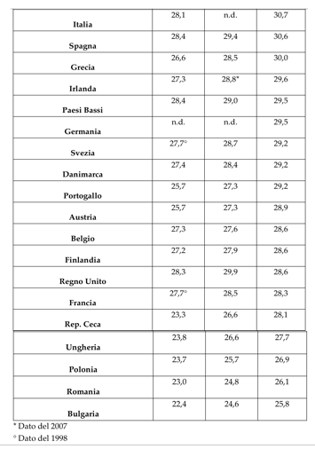
Figure n. 1 ; source: Eurostat (19 May 2016), Età media primo figlio in Europa, on www.lenius.it

Given that Italian women are somewhat late to have their first pregnancy, according to writer-journalist Giulio Meotti, as documented on pages of the Wall Street Journal. Estimates carried out-by the German Max Plack supports that Italy lead by the end of the century a drastic decline in the population shrinking by ten million people. The consequences are the crisis of birth that is happening in our country and that this has consequences both social and economic.
Currently 22% of the Italian population are in retirement age which is one of the highest rates worldwide. Moreover, according the Wall Street Journal, Italy are first in the world living the so-called “crossing over” where it sees the number of those under 20 to be lower than those over 60. According to the newspaper, by 2050, 60 % of Italians will have no brothers, sisters cousins, uncles and aunts.
The social change in our country, such as the permanence of the young, increasingly prolonged, in the family of origin does postpone the realization of the big step. In 2015, 80.9% live in the
family of origin of males 18-30 year olds (over 3 million and 200,000) and 69.7% of their peers (over 2 million and 700,000). Compared to 2014 there are no significant changes.
The prolonged stay of young people in the family of origin, is due to multiple factors, including: the increased duration of education and training, job insecurity and profession, the difficulty of being able to buy a house. Result of the economic crisis that has swept our country in recent years, by postponing marriage and the ability to create an Italian and recording of the young family also of their age.
A survey by Eurostat, of the conditions of young people of the third millennium. The acronym “NEET: Not in Education, Employment or Training” it identifies a band of young people of the third millennium. The “NEET” are young people who do not study, do not have jobs and are not used in training. With the word “NEET” it identifies a specific phase of life that is one in which you move from youth to adult. This phase of the transition, in western society is marked by five major stages that are: leaving the parental home, to complete their education, the entry into the labour market, the formation of a family, taking responsibility to the children. Starting in the seventies, eighties phase in adulthood has started to become increasingly long. If in the past the phases were school, work and family more or less at the same age for all, nowadays the path is much longer, personalized and unpredictable. Certainly this change is due to the great difficulty in entering the world of work, we study a lot more than in the past, we travel more, have more fun. So you grow up later either by necessity or pleasure. Young people “NEET” are children of these social, economic and cultural. Therefore, before coining this new term “NEET” millions of young people lived them carefree transition from young to adulthood without knowing that from now on define “NEET” it meant to be a social problem. The Eurostat reveals how “NEET” are present in Italy and Europe in the 15 to 29 age group, it is an age group that includes young people of school-leavers that are potentially already in a working band. In Italy it appears to be the European country with the highest percentage of young people “NEET”.

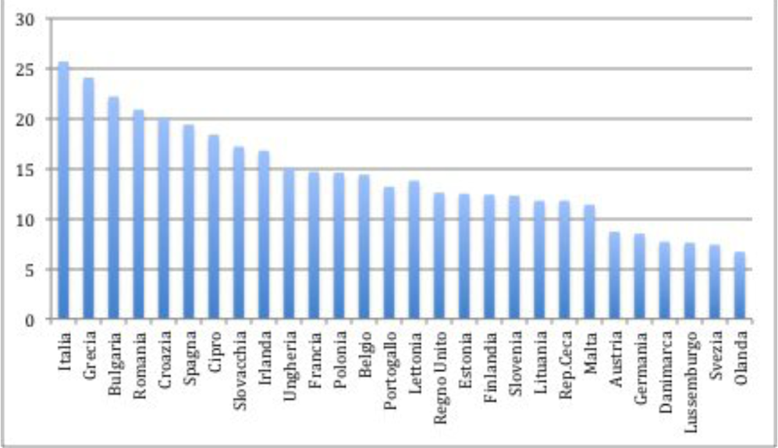
Figure n. 2; source: Eurostat (13 May 2016), Giovani NEET, on www.lenius.it

An Italian out of four between 15 and 29 years do not work nor study, nor is forming. The European average is 14, 8%, unfortunately behind these numbers we do not know the motivation of these young people. According to the Eurostat figures, it is revealed this evolution of the phenomenon, since 2004 were 19.6%, the figure fell to 18, 8% in 2007 and has since risen greatly to 26.2% in 2014, and finally, a 0.5% decline in the last year. What emerges from the study, the greater presence of young people “NEET” is present in the Mediterranean countries of Europe such as Italy, Greece, Portugal, Spain, and a stabilization of the phenomenon in the rest of Europe. This means that there are no global trends everywhere, but more favourable contexts, and others less. Do not forget the crisis of recent years which has particularly affected Mediterranean Europe. Factors affecting the labour market, the organization of the welfare state, also affect socio-cultural factors, such as the role of the family. Summing up, we can say that young people are “NEET” a segment of important and growing population especially in our country and the causes are mainly structural for example, how is the economy and society organized.

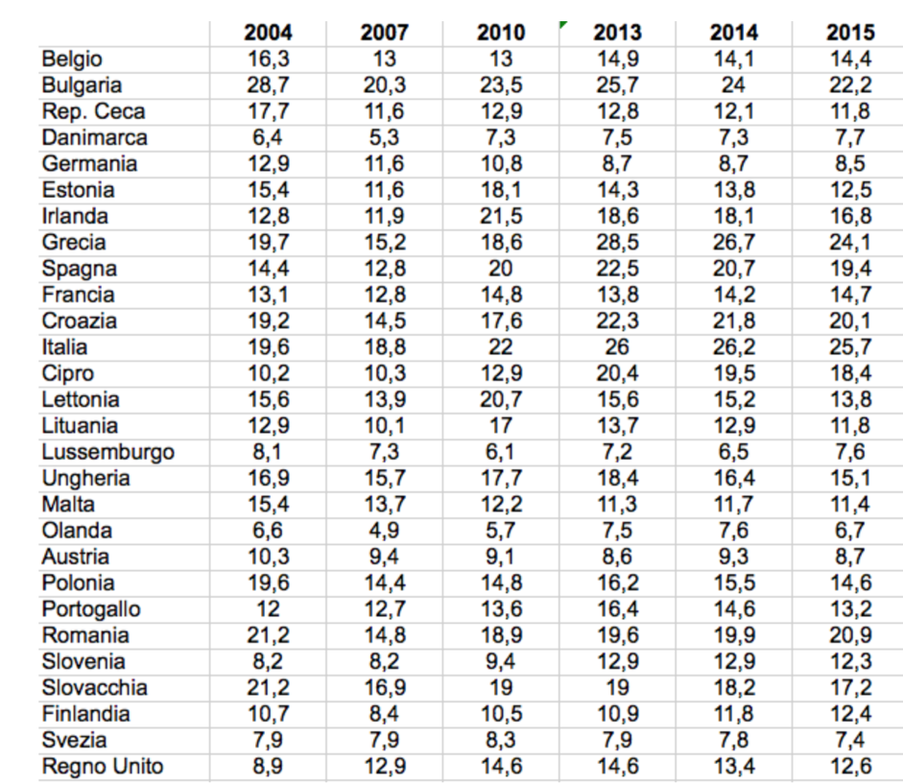
Figure n. 3; source: Eurostat (13 May 2016), Giovani NEET, on www.lenius.it

After a phase so pronounced reference to marriage as that observed from 2009 to 2014, it is possible that there is a partial recovery in 2015 related in some measure to the improvement of general economic conditions, with particular reference to the labour market.
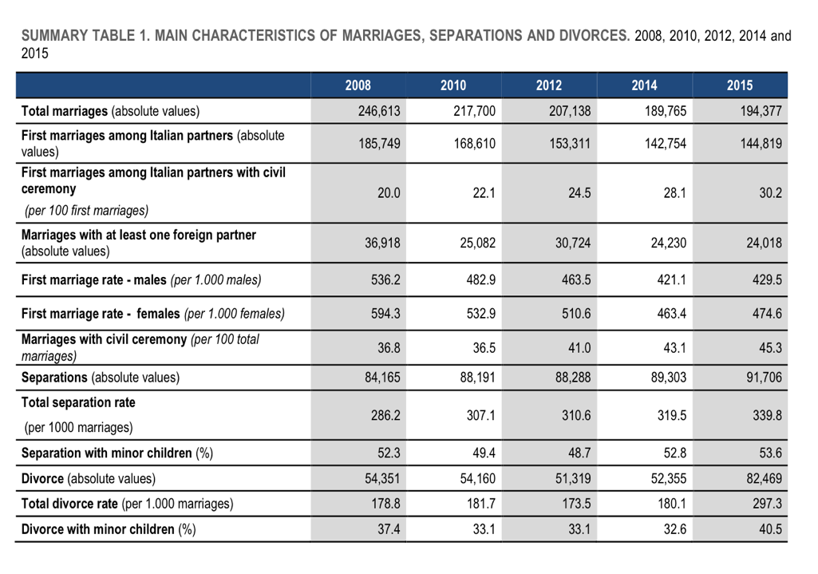
Figure n. 4; source: ISTAT (14 November 2016, p. 2), Marriage, separation and divorce

According to the ISTAT survey, “88 thousand civil ceremonies took place in 2015 and they accounted for 45.3% of all marriages in the same year. Civil weddings registered an increase of 8% compared to 2014 while religious ceremonies continued to decline. This increase was mainly due to second or subsequent marriages. Nevertheless, civil ceremonies are becoming increasingly popular for marriages with both Italian partners marrying for the first time (30% in 2015 compared to 20% in 2008)”. The phenomenon sees the top of the list the northern and central regions. As many as 32% of the spouses who reside in the North-West and 40% of residents in the North-East and the Centre celebrated the first marriage in a civil ceremony in 2015, the South only 20%.
In this regard, it is interesting to quote a survey by CENSIS titled “non mi sposo più”, who claims that her marriage to religious rite will tend to disappear, even assuming a date of death in 2031. This study tells us about the religious marriage crisis in Italy, the rite that is no longer considered necessary in order to create a family. Moreover, according to the Censis claims that in 2020 it will have more civil weddings than religious and that in 2031 will no longer be celebrated only one church wedding. The reasons for this choice, are to be found in social change of our times. Weddings are no longer the primary goal of our life, and also are no longer seen as a constraint on the choice of our life. This change is due to important regulatory processes that protect us even without marrying, for example, children born in and out of wedlock are all legitimate in the same way, cohabitation agreements, equality between married couples and unmarried couples. The Censis, also brings us the presumed date of extinction of religious marriages, the reason is to be found in the lack of interest in the Catholic religion in our country so conservative. The data tell us that, above all 127,936 less than in 1994. In twenty

years, that is, there was a fall of 54% in 2014 in Italy 108 thousand weddings were celebrated in church, 61,593 less than in 2004 of Religious rites.
The marriages with at least one foreign spouse were about 24 thousand (12.4% of all 2015 weddings), 200 fewer than in 2014. The frequency of the marriages with one foreign spouse is higher in areas of the North and Centre, where it is more stable and rooted the presence of various foreign communities. In the Northeast, nearly one marriage in five has at least one foreign spouse, the North-West and the Centre has its quota of 15%, while in the South and the Islands are recorded proportions of 6.3% and at 5, 9% of the total wedding Mixed marriages ,in which one spouse is Italian and other foreign, amounted to more than 17,692 in 2015, representing the largest proportion of marriages with at least one foreign spouse (74%) while those with two foreign partners are more than 6,300.
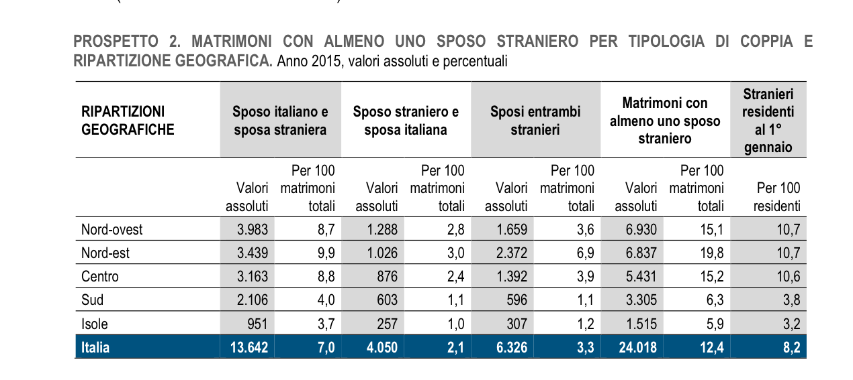
Figure n. 5; source: ISTAT (14 November 2016, p. 5), Matrimoni, separazioni e divorzi

The wedding celebrated in Italy between citizens both foreigners are over 6,000 (3.3% of total marriages) and decreased by a lot when you consider only those in which at least one of them is resident (4,831 in total in wedding 2015). Our country is in fact, an attraction for many people especially from more developed countries, who choose it as a place for the wedding celebration.

Figure n. 6; source: ISTAT (14 November 2016, p. 6), Matrimoni, separazioni e divorzi

    - Separation and Divorce in Italy in 2015

The ISTAT survey, reveals the trend in second marriages that have gradually increasing until
2008 and then there was a slowdown, followed by a slight decrease. In 2015 in Italy are celebrated of “33,579 second or subsequent marriages occurred in 2015, almost 3 thousand more than in 2014 (with an increase of 9%). Their proportion in all marriages reached 17%”. The performance of the second marriage is influenced by the size of the population of so-called “expose at risk” that is , those able to contract a second marriage, and so it is affected both by the first marriage index is the divorce rate. The decline of the first marriage has so far been
offset by the progressive increase of marriages dissolved by divorce. Part of the increase in remarriages of 2015 is to report precisely to the increase of divorces registered in the same year. Emerge that in the Centre-North of Italy, there is a decreasing of first marriage and

civil marriage. In the South of Italy there is an increase of first-marriage rates and less civil marriages and separations. In the “2015 data about marital disruption reflected the impact of recent changes in the regulations. In particular, the introduction of the so called “fast divorce Law” caused a considerable increase in the number of divorces (82,469 compared to 52,355 of the previous year with an increase of 57%). The growth in the number of legal separations was less relevant (91,706 with an increase equal to 2.7% compared to 2014)”. For a correct interpretation of these data should be noted that in 2015 for the first time exert their effects two important changes in laws on separation and dissolution of marriages. The first is the law n. 132/2014, which came into force in late 2014; which aims to simplify the process of separation and consensual divorce procedures providing for the stipulation of-court agreements (for trading Convention assisted by lawyers or directly at the civil registry offices). Spouses can therefore use a simpler process in terms of procedural steps, faster and less costly than the court proceedings. The consequence of the introduction of the extrajudicial agreements for consensual separations and divorces, 27,040 divorces (32.8% of 2015 divorces) and 17,668 separations (19.3% of 2015 separations) were defined at the civil registry offices. These procedures were added to proceedings concluded in the courts (respectively € 55,429 for divorces and 74,038 separations) pushing up considerably the scale of the phenomenon, and above all divorces.
The boom of divorces has indeed contributed a second note changes on “fast divorce Law”, which came into force in mid-2015, which has shortened dramatically (from three years to six

months in cases of consensual separations or one year in the case of judicial separation) the period that must elapse between the mandatory provision of separation and the divorce. This regulatory change has had (and probably will continue to have in the next few years) a “cadence” effect, making anticipate in 2015 a large part of those divorces (with separations completed in the three years from 2013 to 2015) than with the old legislation would see as the periods of time until at least 2016. Almost 40% of divorces defined at the civil registry offices and 10% of those defined in the courts are, in fact, divorces “fast”, or the amount of time elapsed between legal separation and subsequent divorce petition is it was less than three years under the previous legislation. In 2015 there was, therefore, a major shift in the timing of divorce due to changes mentioned regulations.

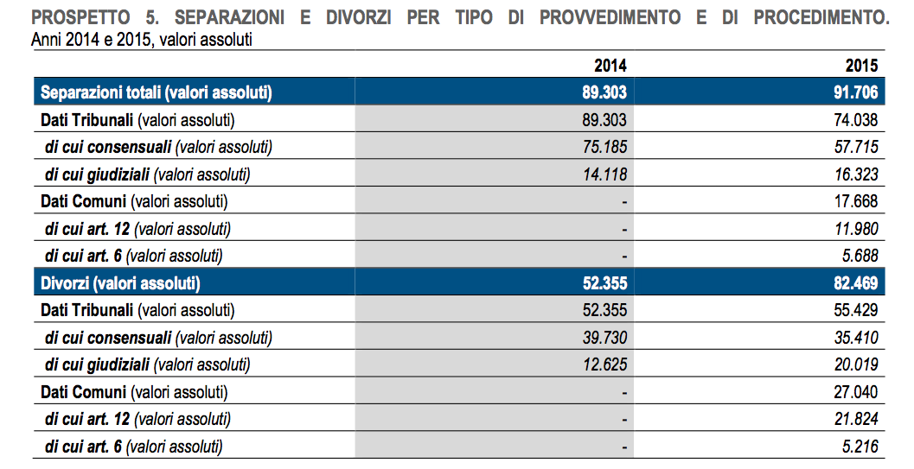
Figure n. 7; source: ISTAT (14 November 2016, p. 8), Matrimoni, separazioni e divorzi

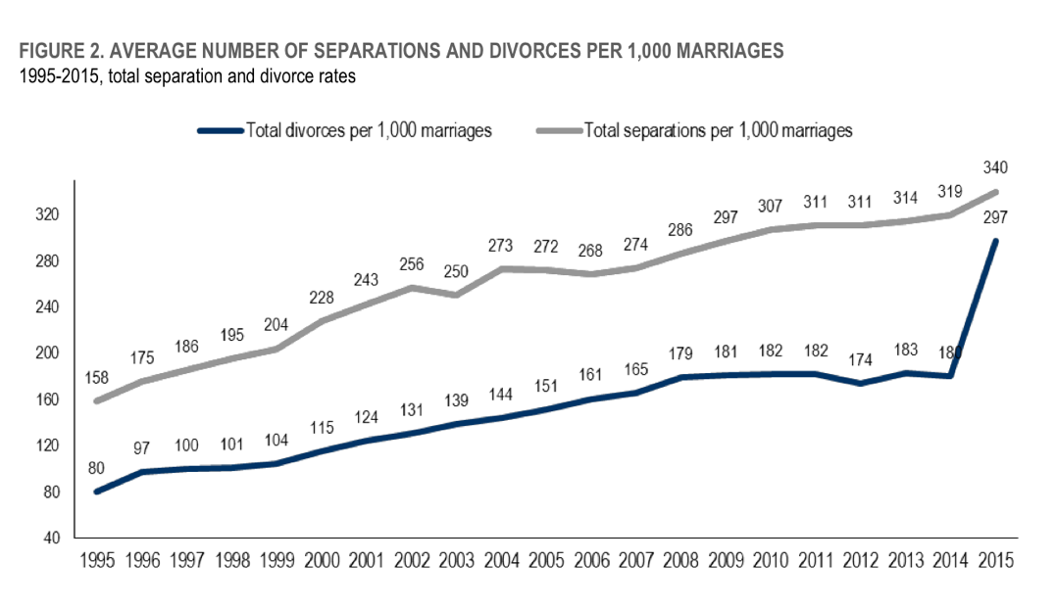
Figure n. 8; source: ISTAT (14 November 2016, p. 3), Marriage, separation and divorce

“The average length of marriages ending in legal separation was approximately 17 years. The
proportion of long-term marriages ended in separation had almost doubled in the last two decades (from 11.3% of 1995 to 23.5% of 2015)”, while the share of those broken down within the first five years of marriage (from 24.4% in 1995 to 12.1% in 2015) . The propensity
to dissolve the marriage, exclude “structure effect” due to the trend of marriages, it is measured by calculating the specific separation rates by duration of marriage, obtained by dividing the separations related to the duration of the marriage to the amount of marriages of corresponding cohort. The breakup of marriages in individual years vary greatly depending on the type of the marriage rite. Comparing the marriages of 1995 with those of 2005, we observe that the propensity to separate is much lower (and stable over time) in marriages celebrated with religious ritual. “The propensity to experience legal separation in religious marriages was stable over time and lower than in civil marriages. After ten years of marriage survivor religious weddings were almost the same for 1995 and 2005 marriage cohorts (respectively 911 and 914 per 1000 marriages) while survivor civil marriages were equal to 861 for 1995

marriage cohort and to 841 for 2005 one.” The rite for analysis shows that the increase in marital instability and the anticipation of the separations for the most recent marriage cohorts, is largely to be referred to the increasing incidence of civil marriages. “In 2015 the average age at legal separation was 48 for men and 45 for women. The largest age group was between 40 and 44 years for wives (18,631 separations, 20.3% of the total) while for husbands was that between 45 and 49 years (18,055, 19.7%)”. In 2000, however, the greatest number of separations both fell for husbands both for wives in class 35-39 years. The 2015 data confirm that to resort to the former article 12 separations were mainly couples of long life: in fact, both for husbands than for wives of the highest percentages are recorded in the age group 60 and over, respectively 25.2% and 18.5%.

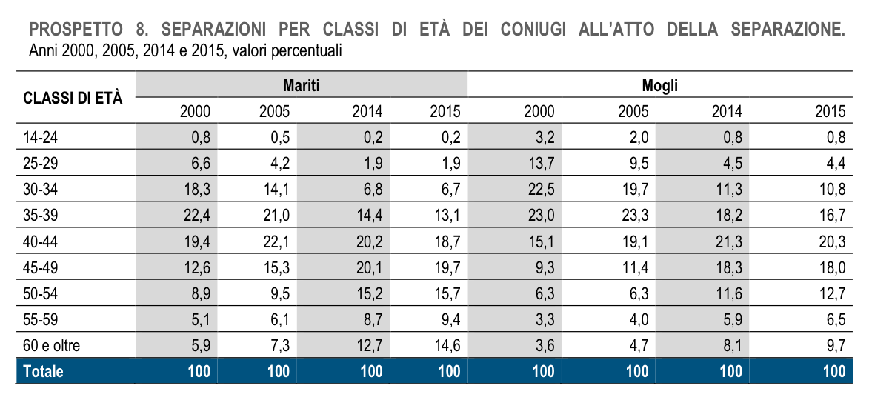
Figure n. 9; source: ISTAT (14 November 2016, p.12), Matrimoni, separazioni e divorzi

The growth of the instability of marriages between spouses of different nationality is a relatively recent phenomenon, due to the increase of “mixed” marriages, like involving Italian and foreign citizens. In 2015, the separation of mixed couples have reached a maximum in absolute terms amounted to 8,657 (in relative terms 9.4% of all separations, a percentage similar to that recorded last year). Seven out of ten (67.7%), the type of mixed couple that could become independent is the one with Italian husband and foreign wife (or who acquired Italian citizenship after her marriage). This result is closely related to the greater propensity of Italian men to marry a foreign citizen. Divorces of “mixed couples”, although increased in absolute
terms (7,160 in 2015), show a tendency to decrease in relative terms. In 2015 they amounted to 8.7% of the total divorces while they were 9.5% of the total in 2014. Just over half of the separations (54.0%) and 39.1% of 2015 divorces concern marriages with at least one child under 18 years. The separations with children in shared custody are approximately 89%. In separations, 52.9% of the children entrusted to less than 11 years. In case of divorce, children are generally bigger: the share of those under 11 years old down to 32.3% of the total. In
2015 the separations with children in shared custody are approximately 89% compared with 8.9% of those with children entrusted exclusively to the mother. The share of loans granted to the father continues to remain at very low levels. Finally, the custody of children to third parties is a residual category that affects less than 1% of children.
Therefore, the youth of the new millennium are in a social situation of the crisis of marriage, the growing number of divorces and the only alternative seem the cohabitation . The reasons for the crisis of marriage, as we have said, can be attributed to many factors, certainly the first among them is the economic crisis and to this is added the crisis of values. The needs of young people of the new millennium are very different from those of the past. For girls, the priority is the education and work, you do not wait as in the past, the arrival of the great love to have their own independence, the same applies to men who marry later and later. We are in a period, which defines the youth eternal “Peter Pan” where it is thirty years since forty years you continue to feel and behave like their twenties years.
It is precisely for these reasons, that marriage survive only where it is seen as an essential tradition. In Italy it is the south that we get married more than the north, surely influenced by cultural factors. From the crisis of marriage, she was born a new era, that of cohabitation. Many couples decide to move in together after a period of engagement also to get used to being together in view of a future marriage. You get to this choice for several reasons both bureaucratic and economic. For example, if a relationship does not last does not make divorce but just let yourself, the other aspect is affordability. Many young people prefer to buy a house and furnish it rather than spending the same amount for a single day, that of marriage.
Although it may seem positive the choice of cohabitation, it must be said, however, that the charm of marriage is incomparable. There is a band of young people who do not surrender to the beauty of marriage, the traditional exchange of rings to the altar and the promise that will last forever.

    - The “Famiglie di fatto” and “Unioni civili” in Italy 2015

In 2008, the “famiglie di fatto” has been one million in the period 2013-2014. In particular, in these period there was over 640.000 cohabitation, have increased ten times compared to the period 1993- 1994. Therefore, official statistics show there are major changes in society. In 2014, increasingly also the “ famiglie di fatto” therefore no married, that have the children, there are 138.680 children.
Figure n.10; source: ISTAT (2014), elaborazione operpolis in Unioni civili
Regarding the “ unioni civili” , a few months of the entry into force the “Cirinnà” Law , the municipality with more celebration is Milan , there are 26 marriages and 102 couples on the waiting list. Then, there are Torino with 19 celebrations and 100 reservations and ultimately Roma that have 9 celebrations and 74 requested and finally Naples with one celebrations and 21 requests. It is a situation which in the future will grow. Following the figure that illustrate the request of “ unioni civili” and “famiglie di fatto” in all Italia’s municipality after the entrance force of the “Cirinnà law”.

Figure n.11; source: Il SOLE 24 ORE (2016), elaborazione su dati dei Comuni in L’italia delle nozze Gay

DANIELE V.(2014), Il significato originale di parole nella lingua italiana, on http://www.etimoitaliano.it
AIRC. ( 2016), Storia e significato del matrimonio , on http://www.matrimoniosolidale.it
The bride accommodate the groom had to answer the question who he was, with formula: <<ubi tu Gaius, ego Gaia>>, signifying his willingness to follow wherever the husband. DE SANTI R. (7 June 2016).
DE SANTI R. (7 June 2016), Storia ed evoluzione del matrimonio on http://www.terremarsicane.it
AIRC. (2016), Storia e significato del matrimonio, cit.
DE SANTI R. (7 June 2016), Storia ed evoluzione del matrimonio, cit.
AIRC. (2016), Storia e significato del matrimonio, cit.
The birth of term “laicizzazione” of marriage, birth in the protestant doctrine, and it refer the separation of the civil aspect and the religious aspect of the marriage. COTINI C. (2001-2014)
COTINI C. ( 2001-2014), Matrimonio Civile, on http://www.studiolegalecotini.it
AIRC. (2016), Storia e significato del matrimonio, cit.
The “concordatario” marriage, it refers to the religious marriage that takes place in front the Minister of Catholic and the Italian’s state law recognizes the same effects of civil marriage. The correct traslate is “Holy marriage with civil recognition”. KLUWER W. I. (2013), Matrimonio religioso.
COTINI C. (2001-2014), Matrimonio Civile, cit.
IL POST (20 Jenuary2016), Cosa dice la costituzione sul matrimonio, on http://www.ilpost.it
IL POST (20 Jenuary2016), Cosa dice la costituzione sul matrimonio, op. ult. cit
IL POST (20 Jenuary2016), Cosa dice la costituzione sul matrimonio, op. ult. cit
AULETTA T. (2014), “La celebrazione del matrimonio”, in Diritto di famiglia Seconda edizione, a cura di G.Giappichelli (pp.19)
AULETTA T. (2014), “La celebrazione del matrimonio”, in Diritto di famiglia Seconda edizione, op.ult.cit (pp.17)
AULETTA T. (2014), “La celebrazione del matrimonio”, in Diritto di famiglia Seconda edizione, op.ult.cit (pp.18)
AULETTA T. (2014), “La celebrazione del matrimonio”, in Diritto di famiglia Seconda edizione, op.ult.cit (pp.19)
AULETTA T. (2014), “La celebrazione del matrimonio”, in Diritto di famiglia Seconda edizione, op.ult.cit (pp.26)
AULETTA T. (2014), “La celebrazione del matrimonio”, in Diritto di famiglia Seconda edizione, op.ult.cit (pp.18)
KLUWER W. I. (2013), “Diritti e risposte per comprendere e risolvere.”, Matrimonio civile, in CORRIERE DELLA SERA, on http:// www.dirittierisposte.it
AULETTA T. (2014), “La celebrazione del matrimonio”, in Diritto di famiglia Seconda edizione, a cura di G.Giappichelli (pp.26)
Article 12: "Men and woman of full age have the right to marry and to found a family", and art. 9 of the Charter of the EU ‘s right. AULETTA T. (2014) “La celebrazione del matrimonio”, in Diritto di famiglia Seconda edizione, op.cit (pp.19-49)
AULETTA T. (2014) “La celebrazione del matrimonio”, in Diritto di famiglia Seconda edizione, op.ul.cit (pp.19)
AULETTA T. (2014) “La celebrazione del matrimonio”, in Diritto di famiglia Seconda edizione, op.cit (pp.21)
AULETTA T. (2014) “La celebrazione del matrimonio”, in Diritto di famiglia Seconda edizione, op.cit (pp.24)
AULETTA T. (2014) “La celebrazione del matrimonio”, in Diritto di famiglia Seconda edizione, op.cit (pp.33-34)
KLUWER W. I. (2013), “Diritti e risposte per comprendere e risolvere.”, Matrimonio civile, in CORRIERE DELLA SERA, op. cit.
KLUWER W. I. (2013), “Diritti e risposte per comprendere e risolvere.”, Matrimonio civile, in CORRIERE DELLA SERA, op. ult. cit.
AULETTA T. (2014) “La celebrazione del matrimonio”, in Diritto di famiglia Seconda edizione, op. cit (pp.34)
KLUWER W. I. (2013), “Diritti e risposte per comprendere e risolvere.”, Matrimonio civile, in CORRIERE DELLA SERA, op.cit.
KLUWER W. I. (2013), “Diritti e risposte per comprendere e risolvere.”, Matrimonio civile, in CORRIERE DELLA SERA, op. ult. cit.
AULETTA T. (2014) “La celebrazione del matrimonio”, in Diritto di famiglia Seconda edizione, op. cit (pp.18)
The act contains the identity of the couple and witnesses, date publication or any indication of the orders granting authorization to the omission of the publication, or if they make use of the obstacles, the place of celebration in cases of imminent danger of death or celebrated outside the Town Hall and, finally, the officer's declaration of marital status that unites them in marriage. KLUWER W. I. (2013), Matrimonio civile.
KLUWER W. I. (2013), “Diritti e risposte per comprendere e risolvere.”, Matrimonio civile, in CORRIERE DELLA SERA, op. ult. cit.
AULETTA T. (2014) “La celebrazione del matrimonio”, in Diritto di famiglia Seconda edizione, op. cit (pp.37-38)
They are excluded from the communion of goods: 1) the assets that each spouse had before marriage; 2) the goods had after marriage by inheritance or donation; 3) the goods of personal use and their accessories; 4) goods used to practice the profession; 5) goods obtained as compensation for damage suffered. The dissolution of community property occurs in any of the following cases: 1) the death of either spouse; 2) judicial separation of property; 3) provision of the approval Court of legal separation of spouses; 4) the divorce decree; 5) marriage annulment; 6) selection of the separation of property regime -to be made by public deed before a notary-. KLUWER W. I. (2013), Matrimonio civile.
This choice must be declared by both spouses, before marriage is communicated the registrar for the civil marriage; at the parish priest for the “concordatario” marriage; the minister for the marriage allowed cults; in case of the after marriage is communicated at notary. The separation of the assets is recorded on the act of marriage and reported in marriage extract. KLUWER W. I. (2013), Matrimonio civile.
The marriage “concordatario”, it refers to the religious marriage that takes place in front the Minister of Catholic and the Italian’s state law recognizes the same effects of civil marriage. KLUWER W. I. (2013), Matrimonio religioso.
State law has recognized the civil effects to marriage “concordatario” in 1929 with the “Concordato Lateranenze”, an agreement between the Italian State and the Holy See, and then overhauled in 1984 with overhauled “Concordato Lateranenze”, agreement called “Villa Madama”. KLUWER W. I. (2013), Matrimonio religioso.
KLUWER W. I. (2013), “Diritti e risposte per comprendere e risolvere.”, Matrimonio Religioso, in CORRIERE DELLA SERA, on http://www.dirittierisposte.it.
After completing the course will receive a certificate of participation, or consent to the marriage by the parish priest at which it was played the course, it is valid for two years and will then be handed over by the bride and groom to their parish priest to when they decide to get married. KLUWER W. I. (2013), Matrimonio Religioso.
KLUWER W. I. (2013), “Diritti e risposte per comprendere e risolvere.”, Matrimonio Religioso, in CORRIERE DELLA SERA, cit.
The marriage, must be preceded by civil publications at the Municipal house by the Civil Code and by church publications to be affixed to the doors of the parish house, both the groom's parish of the bride, if different, for eight days including two Sundays. The registrar, if it finds grounds for celebration of marriage, may decline publications; if, on the contrary there are no impediments, issue the certificate of no impediment to marriage, which is an act in which the registrar declares that there are no causes that oppose the celebration of a valid marriage for civil purposes. KLUWER W. I. (2013), Matrimonio religioso
KLUWER W. I. (2013), “Diritti e risposte per comprendere e risolvere.”, Matrimonio Religioso, in CORRIERE DELLA SERA, cit.
This article is the same for the civil marriage. It is regulated of the Civil Code: art.143, art.144, art. 147. KLUWER W. I. (2013), Matrimonio Civile.
KLUWER W. I. (2013), “Diritti e risposte per comprendere e risolvere.”, Matrimonio Religioso, in CORRIERE DELLA SERA, cit.
AULETTA T. (2014) “La celebrazione del matrimonio”, in Diritto di famiglia Seconda edizione, op. cit (pp.41)
AULETTA T. (2014) “La celebrazione del matrimonio”, in Diritto di famiglia Seconda edizione, op. ult. cit (pp.41)
AULETTA T. (2014) “La celebrazione del matrimonio”, in Diritto di famiglia Seconda edizione, op. ult. cit (pp.42)
KLUWER W. I. (2013), “Diritti e risposte per comprendere e risolvere.”, Matrimonio Religioso, in CORRIERE DELLA SERA, op. cit
KLUWER W. I. (2013), “Diritti e risposte per comprendere e risolvere.”, Matrimonio Religioso, in CORRIERE DELLA SERA, op. ult. cit
The “acattolico” marriage is the marriage taking place in front the minister of a non- catholic worship allowed in the state, for example: Hebrew, Waldensian, Methodist. KLUWER W. I. (2013), Matrimonio acattolico.
AULETTA T. (2014) “La celebrazione del matrimonio”, in Diritto di famiglia Seconda edizione, op. cit (pp.43)
The state law, in the 1159 of 1929 recognized at the “acattolico” marriage the same effects of civil marriage under certain conditions, including the transcript of marriage in the civil status registers. KLUWER W. I. (2013), Matrimonio acattolico.
AULETTA T. (2014) “La celebrazione del matrimonio”, in Diritto di famiglia Seconda edizione, op. cit (pp.43)
The “acattolico” marriage differ in marriages that, to achieve the civil effects, must comply with the procedural formalities laid down by Law number 1159, 1929, for example those celebrated according to the worship of the Christian Congregation of Jehovah's Witnesses, and marriages according to the rites of some religious denominations with which intervened specific agreements which have further simplified the formalities required to give civil validity of the act, such as marriage celebrated by ministers of the Waldensian Church and the Methodist Church, the Seventh Day Adventist Church. KLUWER W. I. (2013), Matrimonio acattolico.
KLUWER W. I. (2013), “Diritti e risposte per comprendere e risolvere.”, Matrimonio Religioso, in CORRIERE DELLA SERA, cit.
The Italian Constitution regulates in Article 29: "The Republic recognizes the rights of the family as a natural society founded on marriage. Marriage is the moral and legal equality of the spouses within the limits established by law and guarantee family unity ". Il Post (2016)
KLUWER W. I. (2013), “Diritti e risposte per comprendere e risolvere.”, Famiglia legittima, in CORRIERE DELLA SERA, on http://www.dirittierisposte.it
AULETTA T. (2014) “I caratteri fondamentali del diritto di famiglia”, in Diritto di famiglia Seconda edizione, a cura di G. Giappichelli (pp. 3)
Legislative Decree 28 December 2013, n. 154 published in the Official Gazette of January 8, 2014, n. 5, on “amending existing legislation in order to eliminate any remaining discrimination remained in our system between children born in and out of wedlock, thus ensuring the full legal equality of the same”. ALTALEX, (9 January 2014). Moreover, the text of the provision states: -the introduction of the principle of the uniqueness of the state of child, adoptive, and consequently the removal of references in the children “legitimate” standards and children “natural” and the establishment of the same with that of “child”; -the principle that filiation out of wedlock successors produces effects in regard to all the relatives and not only with their parents; -replacement of "parental authority news with that of “parental responsibility”; -modifying rules of private international law with a provision of mandatory provisions in implementation of the principle of unification of the state of child. Moreover, in transposing the case-law of the Constitutional Court and the Supreme Court, it was decided to: -imitate five years since the birth of the terms for taking action of denial of paternity; - introduce the right of ascending to maintain "meaningful relationships" with underage grandchildren; - introduce and regulate listening to children, if they are capable of judgment, within the processes that affect them; -lead to ten years the period of limitation for the purposes of acceptance for children born out of wedlock; change matter of succession providing for the abolition of the switch right" on the part of the legitimate children up to date scheduled for the inheritance of illegitimate children. ALTALEX (9 January 2014), Filiazione: in vigore il Dlgs che elimina discriminazioni dei figli naturali, on http://www.altalex.com
KLUWER W. I. (2013), “Diritti e risposte per comprendere e risolvere.”, Famiglia legittima, in CORRIERE DELLA SERA, cit.
KLUWER W. I. (2013), “Diritti e risposte per comprendere e risolvere.”, Famiglia legittima, in CORRIERE DELLA SERA, op. ult.cit.
AULETTA T. (2014) “Caratteri e disciplina della convivenza”, in Diritto di famiglia Seconda edizione, a cura di G.Giappichelli (pp. 151)
KLUWER W. I. (2013), “Diritti e risposte per comprendere e risolvere.”, Famiglia di fatto, in CORRIERE DELLA SERA, on http://www.dirittierisposte.it
Special provisions regulate, from time to time, some aspects of coexistence giving legal significance: -in a criminal trial or domestic partner has the right to refuse to testify against his fellow; -the cohabiting person may petition for the appointment of the partner support administrator; -cohabiting parents exercising parental responsibilities towards their children recognized by both; -domestic partner can take over the lease made out to another, in case of death of the latter; -family actually enjoys the protection of possession (may exercise the actions to ensure their right to own the house) of the house, the place of cohabitation; -in the case of murder of the partner, the other is entitled to compensation; -applies, even for the “famiglie di fatto”, protection against violence in family relations; -family in fact benefits of the "welfare performance" (allocation of public housing etc.); on adoption, the child who is temporarily deprived of a family environment may also be entrusted to a de facto family. KLUWER W. I. (2013), Famiglie di fatto.
The National Council of Notaries that prepared special cohabitation agreements, which can be subscribed as of December 2, 2013 at all notaries in Italy. The contracts go to discipline: the house, the contribution to domestic life, keeping in case of need of the partner, the lease, the ownership of assets, even organizing a regime of community or separation of property. You can predict will also any clauses in favour of the domestic partner or assistance in case of illness through the administrator's support designation. It is also possible to protect the weaker party by contract within the de facto family. KLUWER W. I. (2013), Famiglie di fatto.
KLUWER W. I. (2013), “Diritti e risposte per comprendere e risolvere.”, Famiglia di fatto, in CORRIERE DELLA SERA, cit.
For example, in case of breakage of cohabitation, if you are unable to reach agreement on issues related to children, each of the natural parents may appeal to the Court of minors who may have custody of the child, the right to visit, the child support and the allocation of the family home. KLUWER W. I. (2013)
KLUWER W. I. (2013), “Diritti e risposte per comprendere e risolvere”, Famiglia di fatto, in CORRIERE DELLA SERA, cit.
KLUWER W. I. (2013), “Diritti e risposte per comprendere e risolvere.”, Famiglia di fatto, in CORRIERE DELLA SERA, op. ult. cit
KLUWER W. I. (2013), “Diritti e risposte per comprendere e risolvere.”, Famiglia di fatto, in CORRIERE DELLA SERA, op. ult. cit
Our country is the 27th European country that has legally recognized same-sex couples and regulates the cohabitation outside of marriage. One of the most obvious changes in our legal system to the theme marriage is the new law 20 May 2016 n. 76, the ddl Cirinnà titled "Regulation of civil unions between same-sex and discipline of cohabitation," got the definitive yes to the House. The new law introduces the civil union between homosexuals as a specific social formation and discipline coexistence in fact gay and straight. ADONOPOULOS G. (2016), Unioni civili: cosa dice la legge Cirinnà? Testo completo e novità, on http://www.forexinfo.it
INTERNAZIONALE (11 May 2016), Cosa prevede la nuova legge sulle convivenze, on http://www.internazioanle .it
the new law 20 May 2016 n. 76, the ddl Cirinnà titled "Regulation of civil unions between same-sex and discipline of cohabitation”. ADONOPOULOS G. (2016)
KLUWER W. I. (2013), “Diritti e risposte per comprendere e risolvere.”, Unioni civili, in CORRIERE DELLA SERA, on http://www.dirittierisposte.it.
The address of family life and ordinary residence are agreed between the parties, and the Court in each of them the power to implement the agreed address. KLUWER W. I. (2013), Unioni civili.
KLUWER W. I. (2013), “Diritti e risposte per comprendere e risolvere.”, Unioni civili, in CORRIERE DELLA SERA, op. ult. cit
Among these cases, there are the new spouse's marriage, nullity of remarriage, the provisions relating to nullity of marriage related interdiction, inability to discernment. KLUWER W. I. (2013), Unioni civili.
KLUWER W. I. (2013), “Diritti e risposte per comprendere e risolvere.”, Unioni civili, in CORRIERE DELLA SERA, op. ult. cit
Therefore: - Intestate succession in the discipline provided by art. 565 cc It must be integrated and take into account the plaintiff union. As for the competition between the heirs in the succession is expected that the spouse, “unioni civili” or party, is entitled to half the inheritance if the succession competes with one son and one-third in other cases (art. 581 cc). In case ascendants, brothers or sisters concur with your spouse or “unioni civili” part, to these belong the two-thirds inheritance (art. 582), while in the absence of children, ascendants, brothers or sisters, to spouse or “unioni civili” part is assigned the entire inheritance (art. 583 cc). - In the succession necessary (that is, one where it is the law itself to provide for quotas reserved to specific familiar figures, even in the case of testamentary disinheritance established by the deceased), the position of a “unioni civili” is treated in to that of a spouse. So, to the spouse or to the “unioni civili”, even when competing with other heirs, they reserved the rights of residence on family and home use on the furniture that decorate (art. 540 of the Civil Code). In the event that the dying leaves in addition to the spouse or “unioni civili” of one child, this is for one third of the assets, the same fee is paid to the spouse or “unioni civili”. If the children are more than one to them is reserved half of the assets, while the spouse and the “unioni civili” part is reserved for a quarter of its assets. The division among all the children should be made in equal parts (art. 542 of the Civil Code). As for the competition between the ascending line (i.e: parents) and their spouse or civil union side, in the absence of children, the union civil party or the spouse is reserved half of the assets, while the parents quarter (art. 544). KLUWER W. I. (2013), Unioni civili.
As for the indignity discipline, is excluded from the succession as unworthy who: 1. has voluntarily killed or attempted to kill the person whose estate is involved, his spouse or his “unioni civili” partner, his descendent, an ascendant, unless there are no grounds for excluding criminal liability provided by law; 2. those who have committed against one of these people a fact to which the law declares applicable the provisions of the murder; 3. who has denounced the spouse, the “unioni civili”his sons, an upward for an offense punishable by life imprisonment or an offense for which the law provides imprisonment for not less than three years, and that complaint has been established as false, slanderous and therefore, in a criminal trial. KLUWER W. I. (2013), Unioni civili.
KLUWER W. I. (2013), “Diritti e risposte per comprendere e risolvere.”, Unioni civili, in CORRIERE DELLA SERA, op. ult. cit
KLUWER W. I. (2013), “Diritti e risposte per comprendere e risolvere.”, Unioni civili, in CORRIERE DELLA SERA, op. ult. cit
KLUWER W. I. (2013), “Diritti e risposte per comprendere e risolvere.”, Unioni civili, in CORRIERE DELLA SERA, op. ult. cit
KLUWER W. I. (2013), “Diritti e risposte per comprendere e risolvere.”, Unioni civili, in CORRIERE DELLA SERA, op. ult. cit
QUINZ A. ( 5 February 2016) , I numeri del matrimonio in Italia e di un’industria che ci gira intorno, on http://theweddingenterprise.com
ISTAT-ISTITUTO NAZIONALE DI STATISTICA (14 November 2016), Anno 2015 Matrimoni, separazioni e divorzi, on http://www.istat.it
ISTAT-ISTITUTO NAZIONALE DI STATISTICA (14 November 2016), year 2015 Marriages, separation and divorce, on http://www.istat.it
ISTAT-ISTITUTO NAZIONALE DI STATISTICA (14 November 2016), Anno 2015 Matrimoni, separazioni e divorzi, cit
The inclination of the first marriage, the net of “structure effect” by age of the population is measured by calculating the first-marriage index. The first-marriage index usually is calculating: sum of specific marriage-rate ratios calculated from the ratio, for each age class, of the number of first marriages to the average total annual population. In this case is obtained by dividing the spouses of each age - unmarried at the time of marriage - to the corresponding population masculine and female. In 2014 these indicators showed a record low: have been celebrated the 421 first marriages for 1,000 men and 463 per 1,000 women. The fall comes to 25% if you only observe the first-marriage index of young people below 35 years of age, or the age at which focuses the phenomenon. ISTAT (14 November 2016), Anno 2015 Matrimoni, separazioni e divorzi. “The first marriage rates increased as well, in 2015 there were 429 first marriages per 1,000 men and 474 per 1,000 women (-20% compared to 2008 rates). The mean age at first marriage was 35 for men and 32 for women (that is nearly two years older compared to 2008)”. ISTAT (14 November 2016), year 2015 Marriages, separation and divorce
COLOMBO F. (13 June 2016) , Quando ci si sposa in Italia e in Europa ? , on http://www.lenius.it
“Eurostat is the statistical office of the European Union situated in Luxembourg. Its mission is to provide high quality statistics for Europe. Providing the European Union with statistics at European level that enable comparisons between countries and regions is a key task” EUROSTAT (2016) on http://www.ec.europa.eu
COLOMBO F. (13 June 2016), “Source Eurostat” in Quando ci si sposa in Italia e in Europa? op.ult.cit
COLOMBO F. (13 June 2016), Quando ci si sposa in Italia e in Europa? cit
COLOMBO F. (19 May 2016) , Età media primo figlio in Europa : Italia la più ritardataria, on http://www.lenius.it
COLOMBO F. (19 May 2016), Età media primo figlio in Europa: Italia la più ritardataria, op.ult.cit
MEOTTI G. (7 September 2011), “L’italia è un paese per vecchi” Entro il 2050, saranno 10milioni, in L’editoriale del Wall Street Journal, on http://www1.lastampa.it
MEOTTI G. (7 September 2011), “L’italia è un paese per vecchi” Entro il 2050, saranno 10milioni, in L’editoriale del Wall Street Journal, op.ult.cit
ISTAT-ISTITUTO NAZIONALE DI STATISTICA (14 November 2016), “Indagine Aspetti della vita quotidiana. Anni vari”, in Anno 2015 Matrimoni, separazioni e divorzi, on http://www.istat.it
ISTAT-ISTITUTO NAZIONALE DI STATISTICA (14 November 2016), Anno 2015 Matrimoni, separazioni e divorzi , cit
COLOMBO F. (13 May 2016), “Source Eurostat” in Giovani NEET: chi e quanti sono in Italia e in Europa, on http://www.lenius.it
The acronym appears for the first time in an article in a trade publication in 2002 by tittle Social exclusion and the transition from school to work: the homes of young people Not in Education, Employment, or Training (NEET) written by the authors John Bynner and Samantha Parsons. COLOMBO F. (13 May 2016), Giovani NEET: chi e quanti sono in Italia e in Europa, op.ult.cit
COLOMBO F. (13 May 2016), Giovani NEET: chi e quanti sono in Italia e in Europa, on http://www.lenius.it
COLOMBO F. (13 May 2016), Giovani NEET: chi e quanti sono in Italia e in Europa, op.ult.cit
ISTAT-ISTITUTO NAZIONALE DI STATISTICA (14 November 2016), Anno 2015 Matrimoni, separazioni e divorzi, op. ult. cit
ISTAT-ISTITUTO NAZIONALE DI STATISTICA (14 November 2016), Anno 2015 Matrimoni, separazioni e divorzi, op. ult. cit
ISTAT-ISTITUTO NAZIONALE DI STATISTICA (14 November 2016), year 2015 Marriages, separation and divorce, on http://www.istat.it
CENSIS, Centro Studi Investimenti Sociali, Censis, Social Investment Study Centre, is a socio-economic research institute founded in 1964. Censis held for over fifty years a constant and articulated research, advice and technical assistance in the socio-economic field. This business has developed over the years through the implementation of studies on the social, economic and territorial development, intervention programs and cultural initiatives in the vital areas of social reality: education, work and representation, welfare and health care, the territory and the nets, economic actors, media and communication, public governance, security and citizenship. CENSIS (2016) on htpp://www.censis.it
DE LUCA MN (7 JULY 2016), Matrimonio in calo costante: il 2031 l’anno zero, in La Repubblica, on http://www.repubblica.it
DE LUCA MN. (7 JULY 2016), Matrimonio in calo costante: il 2031 l’anno zero, in La Repubblica, op.ult.cit
In mixed marriage, the most common type is one in which the groom is Italian and the bride is foreign, about the 7% of the wedding celebrated in 2015 at the national average level, and about 9% in the north and centre. Italian women who have chosen a foreign partner are 4,050 in 2015, the 2.1% of the total of the brides: the latter type of unions shows the sharpest decline since 2008 (when there were more than 6,300). ISTAT (14 November 2016), Anno 2015 Matrimoni, separazioni e divorzi.
ISTAT-ISTITUTO NAZIONALE DI STATISTICA (14 November 2016), Anno 2015 Matrimoni, separazioni e divorzi ,cit
ISTAT-ISTITUTO NAZIONALE DI STATISTICA (14 November 2016), year 2015 Marriages, separation and divorce, on http://www.istat.it
ISTAT-ISTITUTO NAZIONALE DI STATISTICA (14 November 2016), Anno 2015 Matrimoni, separazioni e divorzi ,cit
The men remarry more frequently than women, on average, to 53 years if they are divorced, and at 69 if they are widowed, while women the second marriage have, on average, 46 years if divorced and 54 years if widows. The most common type between successive marriages to the first is that in which the groom is divorced and the bride's maiden name (more than 12, 000 wedding, 6.3% of marriages in 2015), while almost 10,000 (5.1 % of the total) celebrations in which the bride and groom to be divorced is unmarried. ISTAT (14 November 2016), Anno 2015 Matrimoni, separazioni e divorzi
ISTAT-ISTITUTO NAZIONALE DI STATISTICA (14 November 2016), year 2015 Marriages, separation and divorce, on http://www.istat.it
Law Decree 12 September 2014, n. 132 on "Urgent Measures of diversion is conditional and other interventions for the definition of the backlog in civil process", converted with amendments by Law 10 November 2014, n. 162. The law provides, in fact, the use of extra-judicial agreements only in cases of consensual separation and divorce, and it regulates two different procedures, more or less streamlined, depending on whether the couple there is the presence (procedure under article 6) or absence (procedure ex article 12) of minor children or older dependents or equity agreements. ISTAT-ISTITUTO NAZIONALE DI STATISTICA (14 November 2016), Anno 2015 Matrimoni, separazioni e divorzi
The lawyer of the party is obliged to transmit, within a period of ten days, the civil officer of the municipality in which the marriage was entered or transcribed, copy certified by the same agreement. The convention will be transcribed in the register of civil status within 30 days of receipt. ISTAT-ISTITUTO NAZIONALE DI STATISTICA (14 November 2016), Anno 2015 Matrimoni, separazioni e divorzi
It was published in the Official Journal of 11 May 2015, n. 107 so-called Law on Divorce short (Law May 6, 2015, n. 55), which acts on the regulation of separation and divorce, reducing the time for a divorce three years to twelve months in the case of judicial separation and six months in the case of consensual separations (also in case of processing by judicial in consensual) ISTAT-ISTITUTO NAZIONALE DI STATISTICA (14 November 2016), Anno 2015 Matrimoni, separazioni e divorzi ,
ISTAT-ISTITUTO NAZIONALE DI STATISTICA (14 November 2016), Anno 2015 Matrimoni, separazioni e divorzi ,cit
ISTAT-ISTITUTO NAZIONALE DI STATISTICA (14 November 2016) , year 2015 Marriages, separation and divorce, on http://www.istat.it
In particular, considering data from 2015 to measure adopted (judgment / decree of the court or out of court settlement), to make use of the former article 12 court procedure, namely that provided for in the absence of minors or adult children dependents or equity agreements, are predominantly married couples recently (23.4% for married couples from 0 to 4 years) or, on the contrary, long-time (31.6% among those married for more than 25 years) in which children , if any, have already left the family home. ISTAT (14 November 2016), Anno 2015 Matrimoni, separazioni e divorzi
ISTAT-ISTITUTO NAZIONALE DI STATISTICA (14 November 2016), year 2015 Marriages, separation and divorce, on http://www.istat.it
ISTAT-ISTITUTO NAZIONALE DI STATISTICA (14 November 2016), year 2015 Marriages, separation and divorce, op.ult.cit
ISTAT-ISTITUTO NAZIONALE DI STATISTICA (14 November 2016), Anno 2015 Matrimoni, separazioni e divorzi, op. ult. cit
It should be noted that the detection of separations and divorces performed by Istat only considers cases concluded in Italy. The proceedings concluded abroad to escape detection; This phenomenon can probably be more frequent in the case of mixed couples. ISTAT-ISTITUTO NAZIONALE DI STATISTICA (14 November 2016), Anno 2015 Matrimoni, separazioni e divorzi
As for the type of custody, in the past decade there has been a sharp turnaround in both separations divorces. In fact, with the entry into force of Law 54/2006, was introduced as a regular mode, the institution of foster care of minor children shared between the couple. Under the new law both ex-spouse’s parents retain parental authority (formerly vested in the custodial parent) and must provide for the economic livelihood of their children in proportion to income. Until 2005, it was the sole custody of the minor children to the mother the type widely prevalent. In 2005, the minor children were entrusted to the mother 80.7% of separations and divorces nell'82,7%, with higher percentages in the South than in the rest of the country. The only parental custody has shown residual even compared to custody jointly or alternately, resulting in 3.4% to 5.1% in separations and divorces. Starting in 2006, coinciding with the introduction of the new law, the share of loans granted to the mother is strongly reduced in favour of foster shared. The "overtaking" real occurred in 2007 (72.1% of separations with children in shared custody against 25.6% of those with children entrusted exclusively to the mother), and then consolidated further. Already in 2010 we are seeing a drastic reduction in the percentage of children entrusted exclusively to the mother, 9.0%, a trend that was consolidated in the following years. ISTAT (14 November 2016), Anno 2015 Matrimoni, separazioni e divorzi
ISTAT-ISTITUTO NAZIONALE DI STATISTICA (14 November 2016) , Anno 2015 Matrimoni, separazioni e divorzi ,cit
TOGNI M. (2016), Sposarsi o convivere?, on http//:www.marcotogni.it
TOGNI M. (2016), Sposarsi o convivere? op.ult.cit
PEDULLA’ G. (2 May 2016), Unioni civili, il 9 maggio riparte la discussione, on http://www.lanotiziagiornale.it
DI SANZO D. (28 September 2016), Unioni civili : dopo due mesi i numeri non decollano , in LA STAMPA ITALIA , on http:// www.lastampa.it

